**CS 2302 Data Structures**

**Fall 2019**

**Lab Report #6**

Due: November 19th, 2019

Professor: Olac Fuentes

TA: Anindita Nath

**Introduction**

For this lab, we were asked to implement all possible solutions for the fox, chicken, and grain riddle as an undirected and unweighted graph. The graph will be represented as an adjacency list, an adjacency matrix, or an edge list, and the solutions to the riddle will be represented as a path (a list of integers) found by breadth-first search and depth-first search. For this lab, it is key to remember the properties that adjacency lists, adjacency matrices, and edge lists use to represent graphs as well as the properties that breadth-first search and depth-first search algorithms use to traverse a graph in order to find a path. The main objective of this lab is to implement and compare six different algorithms that use the three graph representations and the two search algorithms to find the solutions to the riddle.

**Proposed Solution Design and Implementation**

**Operation #1 (Breadth-first search using an adjacency list representation of the graph):**

For this operation, I implemented a breadth-first search algorithm that traverses through an undirected, unweighted graph and accesses its vertices using an adjacency list representation. To do this, I initialized an empty queue that holds all the vertices that will be visited, a list of boolean values initialized to False that holds the vertices that have been visited, and list of integers initialized to -1 that keeps track of the path traversed by breadth-first search. At the start of the algorithm, the starting vertex (vertex 0) is appended to the queue and its corresponding value in the known list is set to True, indicating that the vertex has been visited. While the queue is not empty, the algorithm pops a vertex from the queue and sets it as the current vertex. For every vertex adjacent to the current vertex, which is represented in a list of edges at the position in the adjacency list dictated by the current vertex, the algorithm checks if the adjacent vertex has been visited. If it has not been visited, the algorithm uses the “dest” attribute of the adjacency list to append the adjacent vertex to the queue, set its corresponding value in the known list to True, and set its corresponding value in the path list to the current vertex. Once all vertices have been visited, the algorithm returns the path list created by breadth-first search.

The time complexity of this operation for a graph G = (V,E) is **O(|V| + |E|)** because it traverses through the graph by visiting every vertex at most once and every edge between adjacent vertices to build all paths possible from one vertex to another vertex.

**Operation #2 (Depth-first search using an adjacency list representation of the graph):**

For this operation, I implemented a depth-first search algorithm that traverses through an undirected, unweighted graph and accesses its vertices using an adjacency list representation. To do this, I initialized an empty stack that holds all the vertices that will be visited, a list of boolean values initialized to False that holds the vertices that have been visited, and list of integers initialized to -1 that keeps track of the path traversed by depth-first search. At the start of the algorithm, the starting vertex (vertex 0) is appended to the stack. While the stack is not empty, the algorithm pops a vertex from the stack and sets it as the current vertex. Afterwards, it checks if the current vertex has been visited before. If it has not been visited, the algorithm sets its corresponding value in the known list to True and continues to search for the vertices adjacent to the current vertex. For every adjacent vertex, which is represented in a list of edges at the position in the adjacency list dictated by the current vertex, the algorithm uses the “dest” attribute of the adjacency list to append the adjacent vertex to the stack and set its corresponding value in the path list to the current vertex if the adjacent vertex has not been visited. Once all vertices have been visited, the algorithm returns the path list created by depth-first search.

The time complexity of this operation for a graph G = (V,E) is **O(|V| + |E|)** because it traverses through the graph by visiting every vertex at most once and every edge between adjacent vertices to build all paths possible from one vertex to another vertex.

**Operation #3 (Breadth-first search using an adjacency matrix representation of the graph):**

For this operation, I implemented a breadth-first search algorithm that traverses through an undirected, unweighted graph and accesses its vertices using an adjacency matrix representation. To do this, I repeated the same steps as I did for the previous breadth-first search algorithm before this algorithm started to traverse through the graph. While the queue is not empty, the algorithm pops a vertex from the queue and sets it as the current vertex. For every vertex adjacent to the current vertex, which is represented as a positive integer in the row of the adjacency matrix dictated by the current vertex, the algorithm checks if there is an edge between the current and adjacent vertices and if the adjacent vertex has been visited. If there is an edge between vertices and if the adjacent vertex has not been visited, the algorithm uses the index of the current row in the adjacency matrix to append the adjacent vertex to the queue, set its corresponding value in the known list to True, and set its corresponding value in the path list to the current vertex. Once all vertices have been visited, the algorithm returns the path list created by breadth-first search.

The time complexity of this operation for a graph G = (V,E) is **O(|V|2)** because it traverses through the graph by visiting every vertex at most once and checking if there is an edge

between two vertices for every vertex to build all paths possible from one vertex to another vertex.

**Operation #4 (Depth-first search using an adjacency matrix representation of the graph):**

For this operation, I implemented a depth-first search algorithm that traverses through an undirected, unweighted graph and accesses its vertices using an adjacency matrix representation. To do this, I repeated the same steps as I did for the previous depth-first search algorithm up to the point where the algorithm starts to search for the vertices adjacent to the current vertex. For every adjacent vertex, which is represented as a positive integer in the row of the adjacency matrix dictated by the current vertex, the algorithm checks if there is an edge between the current and adjacent vertices. If there is such an edge, the algorithm uses the index of the current row in the adjacency matrix to append the adjacent vertex to the stack and set its corresponding value in the path list to the current vertex if the adjacent vertex has not been visited. Once all vertices have been visited, the algorithm returns the path list created by depth-first search.

The time complexity of this operation for a graph G = (V,E) is **O(|V|2)** because it traverses through the graph by visiting every vertex at most once and checking if there is an edge

between two vertices for every vertex to build all paths possible from one vertex to another vertex.

**Operation #5 (Breadth-first search using an edge list representation of the graph):**

For this operation, I implemented a breadth-first search algorithm that traverses through an undirected, unweighted graph and accesses its vertices using an edge list representation. To do this, I repeated the same steps as I did for the previous two breadth-first search algorithms before this algorithm started to traverse through the graph. While the queue is not empty, the algorithm pops a vertex from the queue and sets it as the current vertex. For every vertex adjacent to the current vertex, which is represented in an edge of the edge list as either the “source” attribute or the “dest” attribute, the algorithm checks if the value of the “source” attribute matches the current vertex. If the two values do not match, then it checks if the value of the “dest” attribute matches the current vertex. Once the two values match in either case, the algorithm checks if the adjacent vertex has been visited. If it has not been visited, the algorithm uses the corresponding “source” and “dest” attributes of the edge list to append the adjacent vertex to the queue, sets its corresponding value in the known list to True, and sets its corresponding value in the path list to the current vertex. Once all vertices have been visited, the algorithm returns the path list created by breadth-first search.

The time complexity of this operation for a graph G = (V,E) is **O(|V| + |E|)** because it traverses through the graph by visiting every vertex at most once and every edge between adjacent vertices to build all paths possible from one vertex to another vertex.

**Operation #6 (Depth-first search using an edge list representation of the graph):**

For this operation, I implemented a depth-first search algorithm that traverses through an *undirected, unweighted graph and accesses its vertices using an edge list representation. To do* this, I repeated the same steps as I did for the previous two depth-first search algorithms up to the point where the algorithm starts to search for the vertices adjacent to the current vertex. For every adjacent vertex, which is represented in an edge of the edge list as either the “source” attribute or the “dest” attribute, the algorithm checks if the value of the “source” attribute matches the current vertex. If the two values do not match, then it checks if the value of the “dest” attribute matches the current vertex. Once the two values match in either case, the algorithm uses the corresponding “source” and “dest” attributes of the edge list to append the adjacent vertex to the stack and set its corresponding value in the path list to the current vertex if the adjacent vertex has not been visited. Once all vertices have been visited, the algorithm returns the path list created by depth-first search.

The time complexity of this operation for a graph G = (V,E) is **O(|V| + |E|)** because it traverses through the graph by visiting every vertex at most once and every edge between adjacent vertices to build all paths possible from one vertex to another vertex.

In order to test these six operations, I created a main file that that creates an undirected, unweighted graph containing all possible vertices from 0 to 15 and the edges that connect legal states with each other. After the initial graph is created, the program displays its corresponding representation to the terminal and shows what the graph looks like by calling the corresponding *display()* and *draw()* functions, respectively. It should be noted that the *draw()* function is intended to work for adjacency lists. Therefore, the *draw()* function for the other two graphs representations works by calling the *as_AL()* function in their respective class to convert the current graph representation to an adjacency list representation and calling the *draw()* function of the adjacency list class. Afterwards, the program calls the breadth-first search and depth-first search functions with their corresponding graph representation to obtain the path needed to traverse through the graph to reach vertex 15 from vertex 0. Additionally, I implemented two additional functions that help show the path traversed for each search algorithm. The *printPath()* function takes the path obtained by either search algorithm and returns a list containing the vertices that needed to be visited in order to traverse the graph from vertex 0 to vertex 15. The *pathToGraph()* function takes the list obtained from the previous functions and builds a graph for that path by inserting an edge between every vertex at the current position (source vertex) and the vertex at the next position (destination vertex). Once the path has been converted to a graph, the program displays the graph representation of the path and shows what the graph looks like by calling the corresponding *display()* and *draw()* functions, respectively.

In addition to the six operations, we were asked to test the implementation of certain functions for the three classes of graph representations. Specifically, we were asked to compare the performance of the *insert_edge()*, *display()*, and *delete_edge()* functions. To do this, I created another main file that creates four types of graphs of varying sizes. The four types of graphs are as follows: unweighted and undirected, unweighted and directed, weighted and undirected, and weighted and directed. The sizes of the graphs are dictated by the number of vertices inserted into the graph. In order to compare the performance of the three graph representations, I imported each graph representation class at a time and ran the program with that specific graph representation. That way, the program can build the graphs, display their corresponding representation to the terminal, delete an edge from the graph, and display the running times of these three operations in nanoseconds. Additionally, I added the *draw()* function to this program to show what the actual graph looks like with its vertices, edges, and edge weights, if applicable.

**Experimental Results**

**Part 1**

In this part, I will test graphs that have 6, 12, and 18 vertices and are unweighted and undirected, unweighted and directed, weighted and undirected, and weighted and directed to test and compare the performance of the *insert_edge()*, *display()*, and *delete_edge()* functions in each of the graph representation classes. For the *delete_edge()* function, the same edge (from vertex 1 to vertex 2) was deleted across all runs of the program.

Graph representation: Adjacency list; Size of graph: 6 vertices

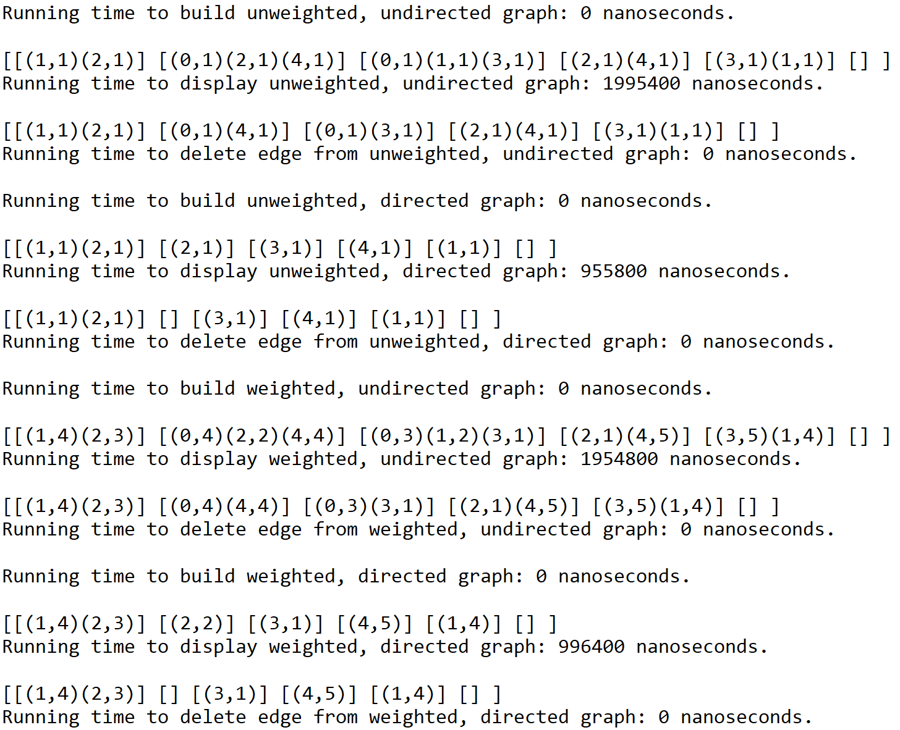

Graph representation: Adjacency matrix; Size of graph: 6 vertices

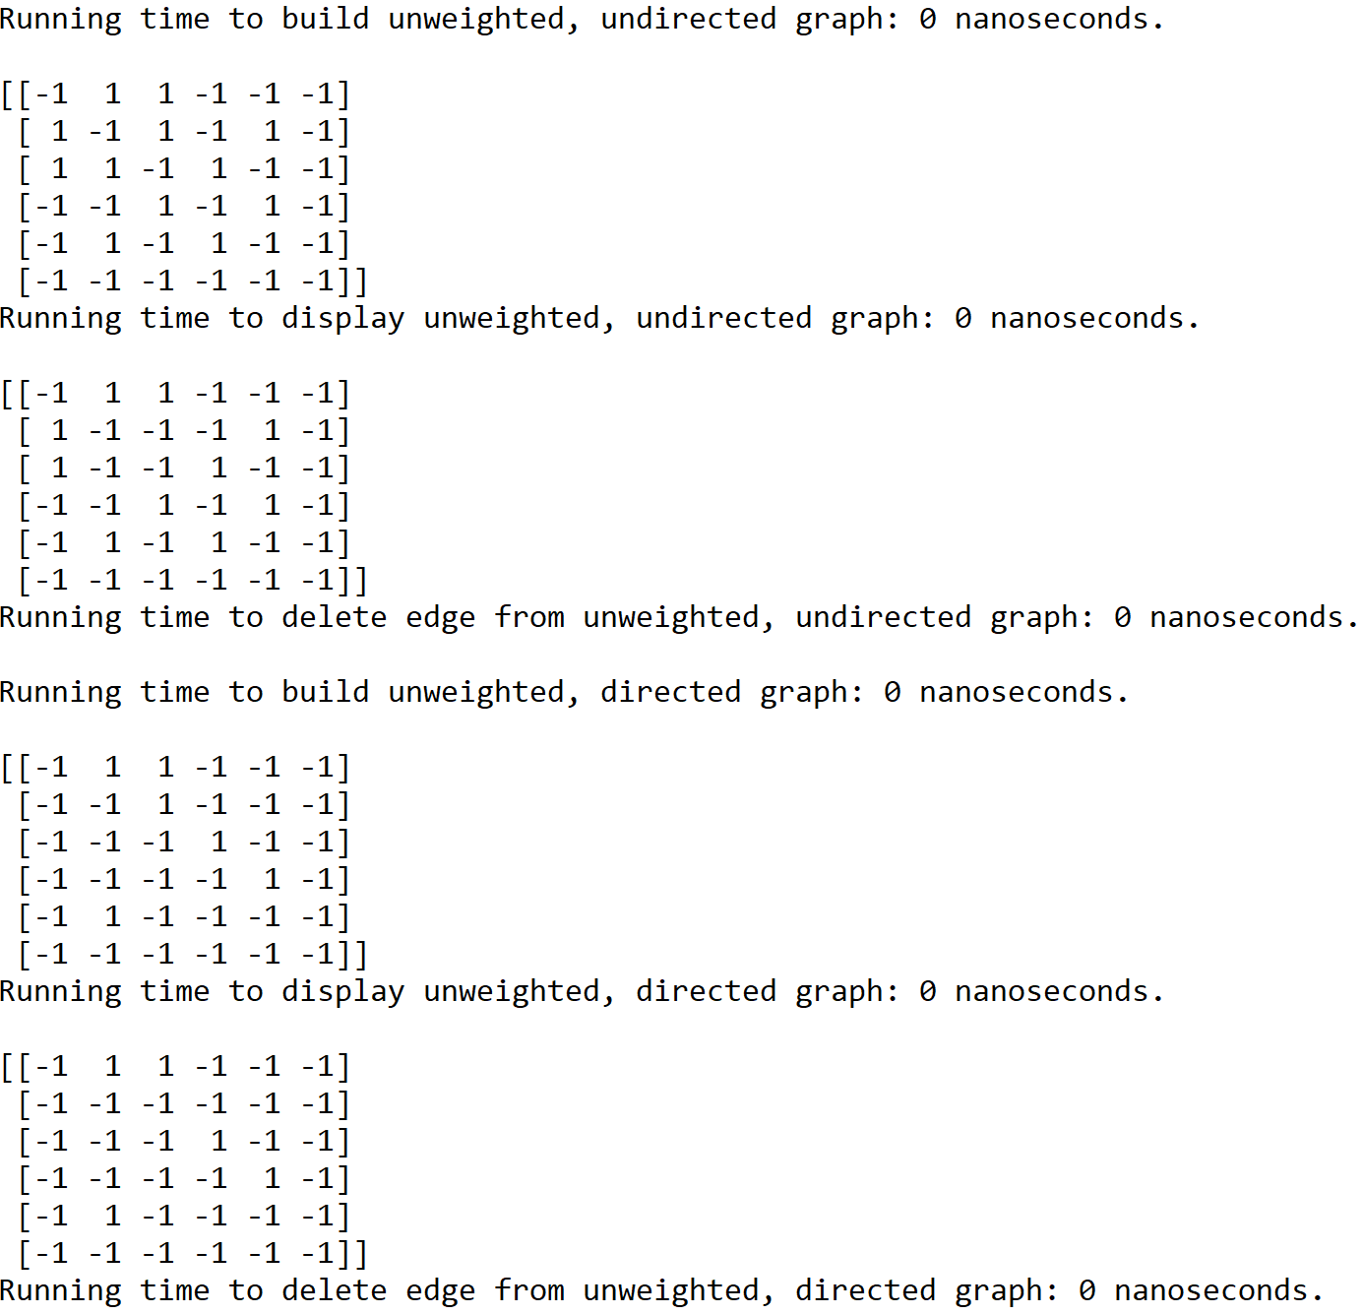

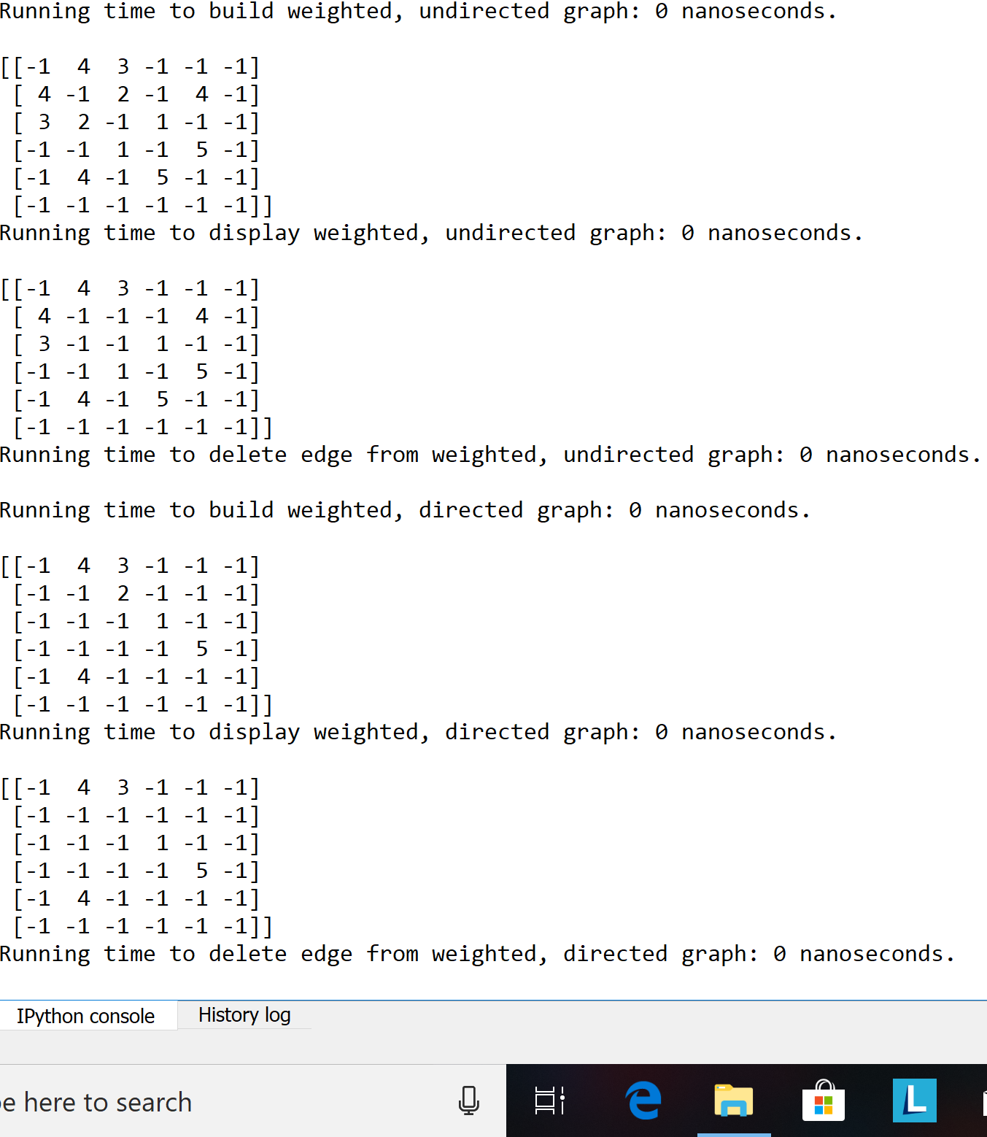

Graph representation: Edge list; Size of graph: 6 vertices

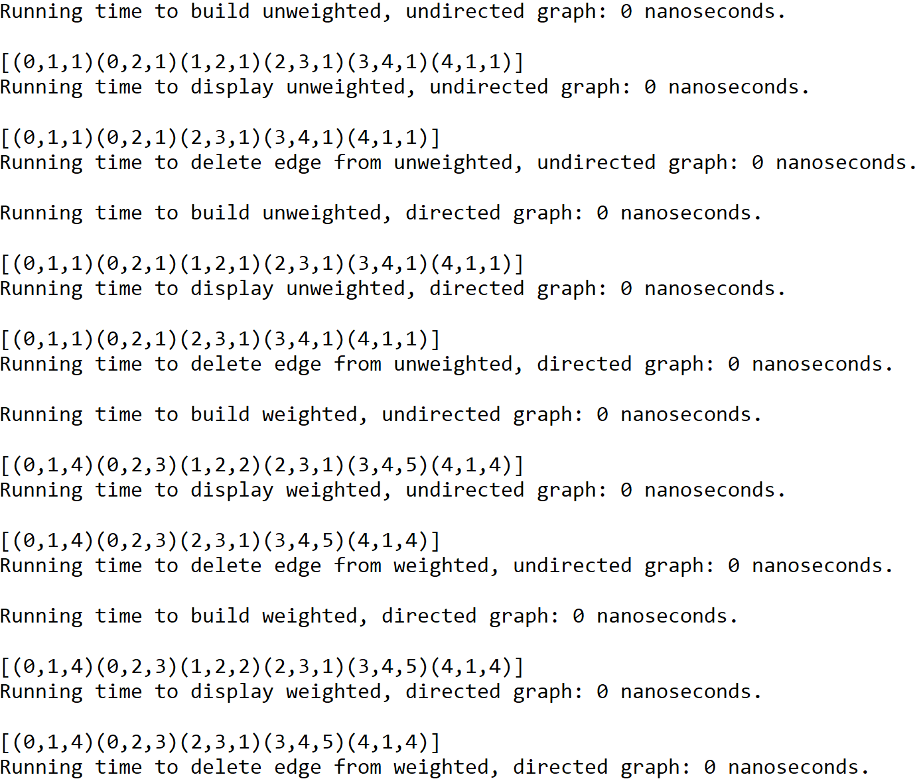

Graph representation: Adjacency list; Size of graph: 12 vertices

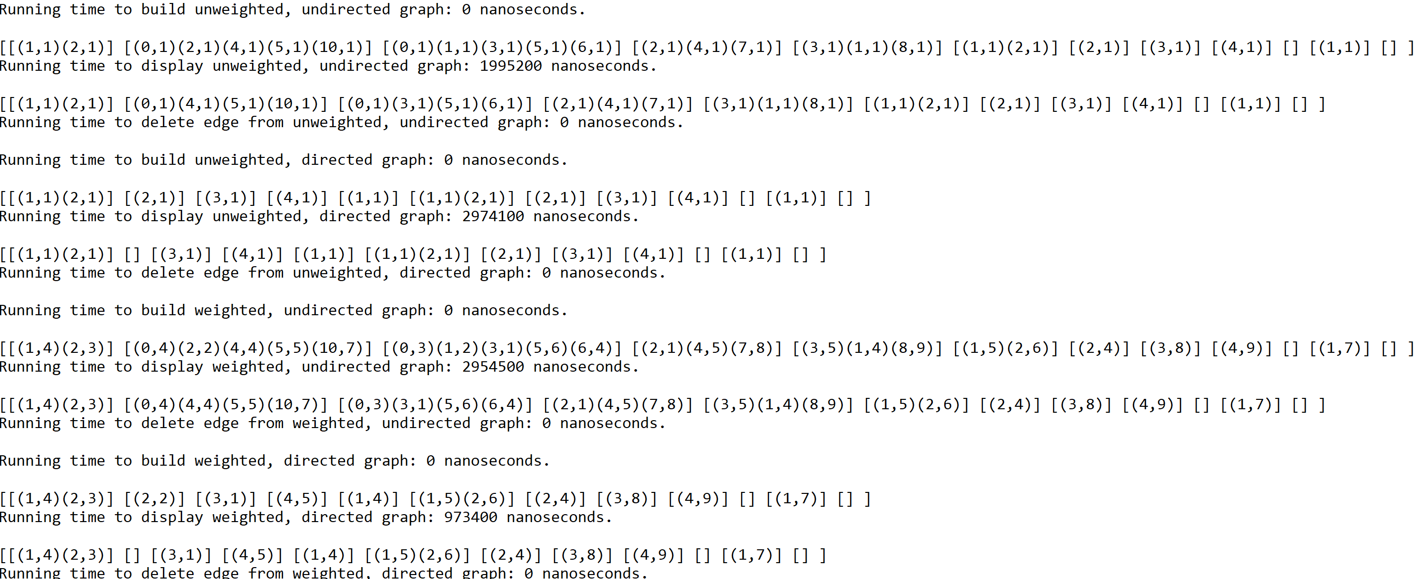

Graph representation: Adjacency matrix; Size of graph: 12 vertices

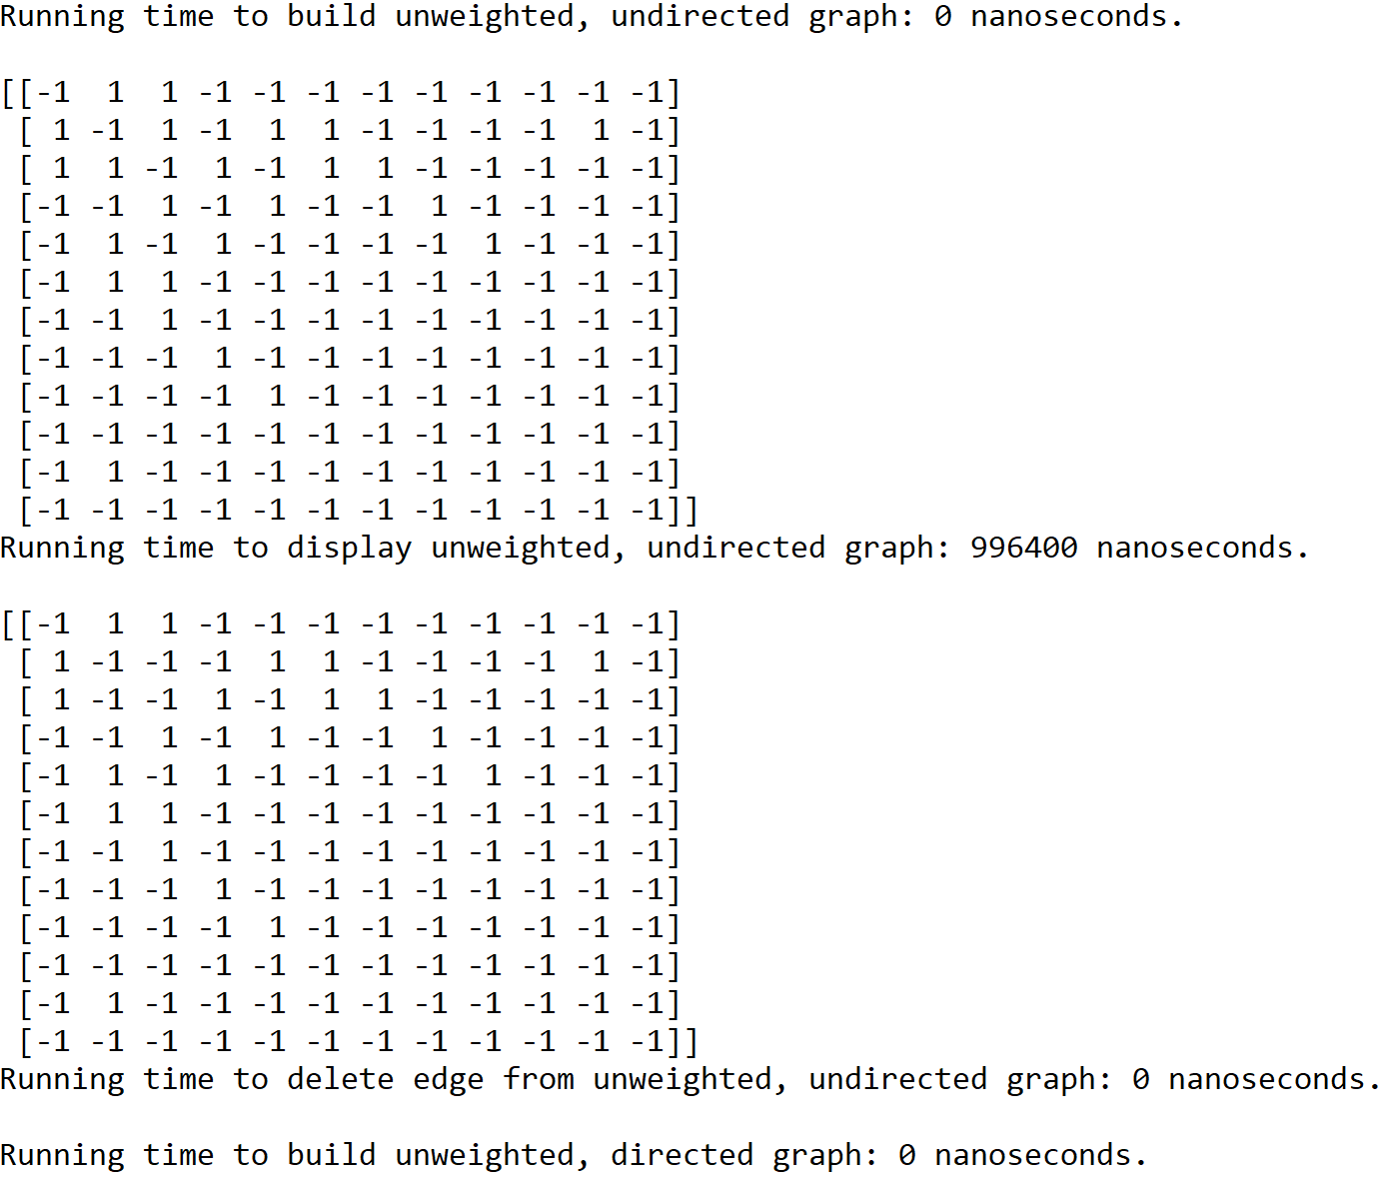

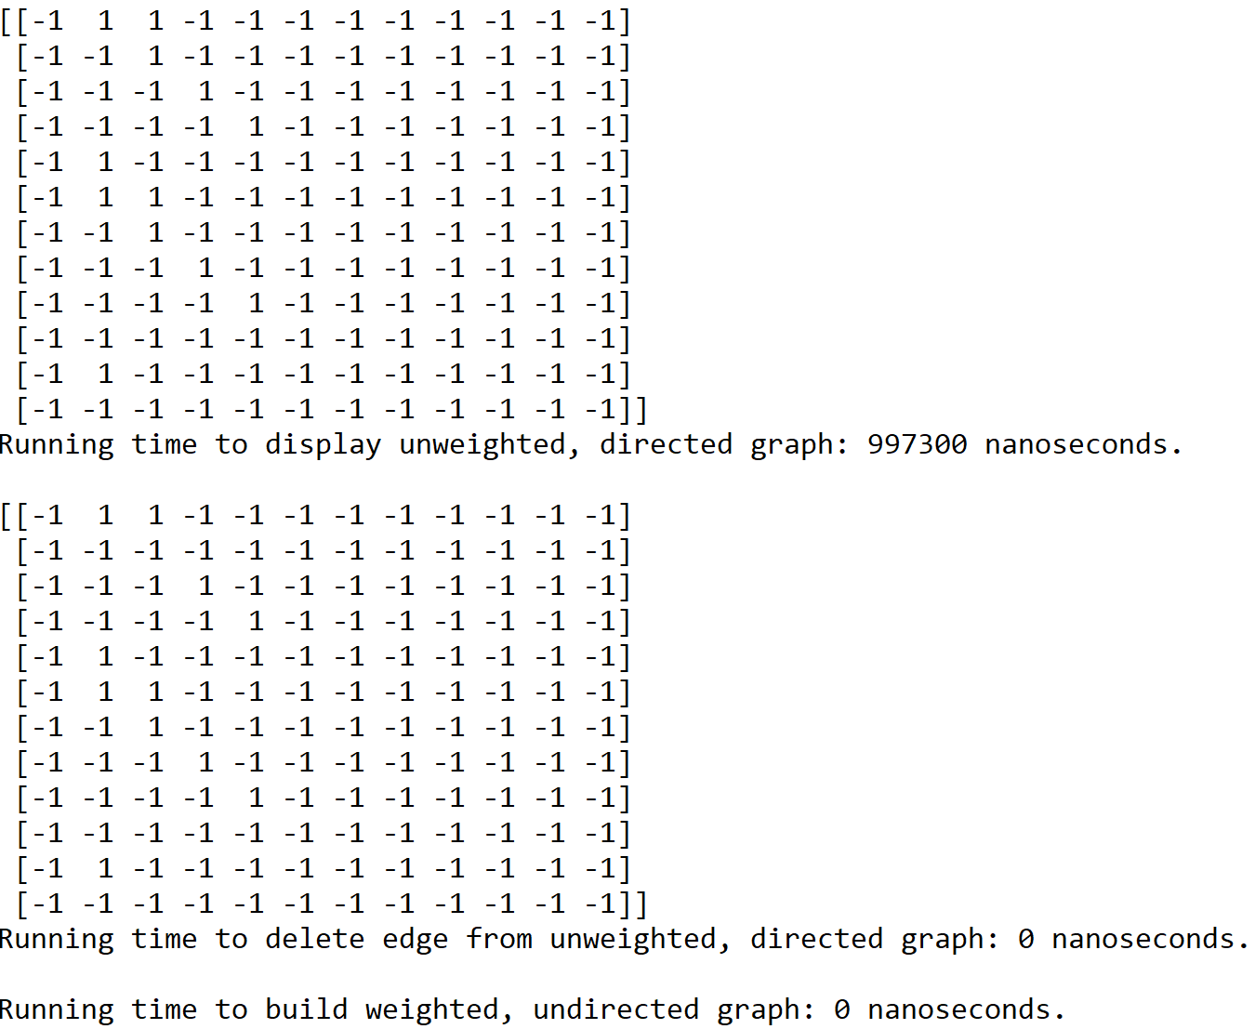

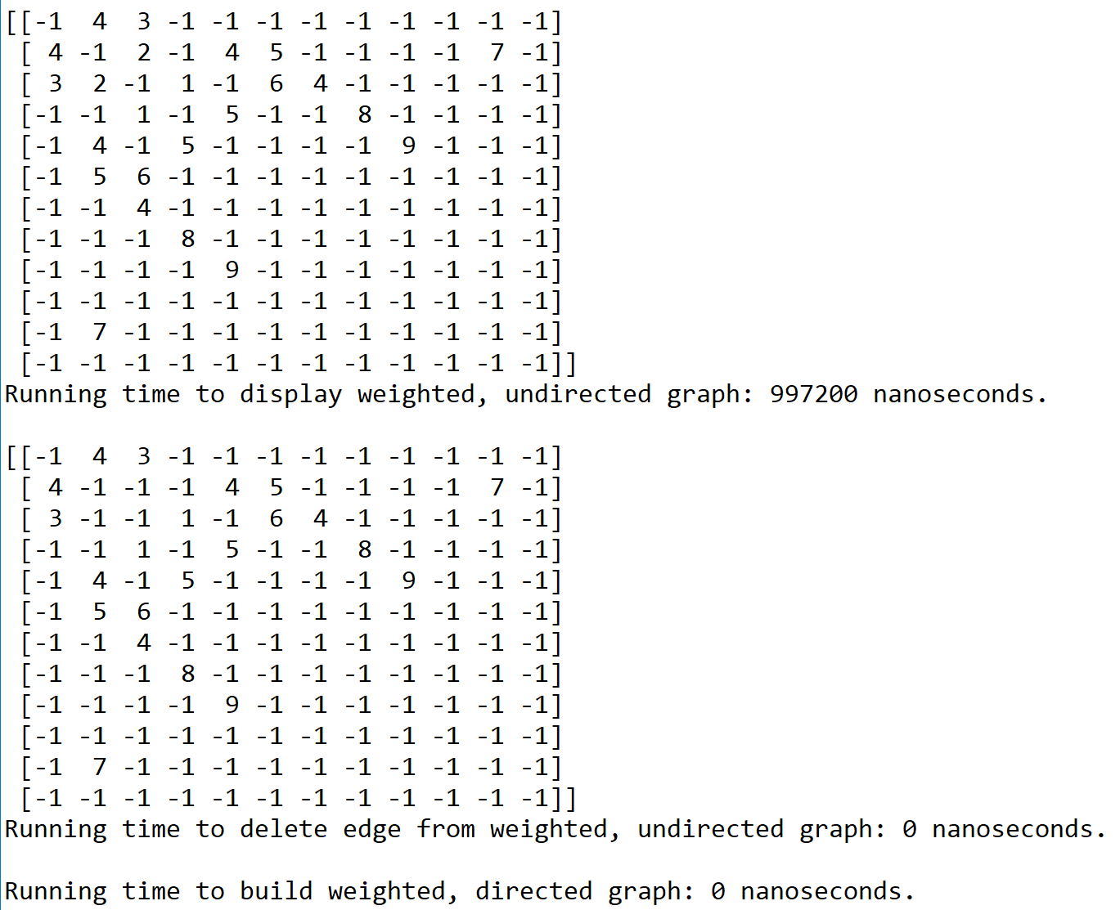

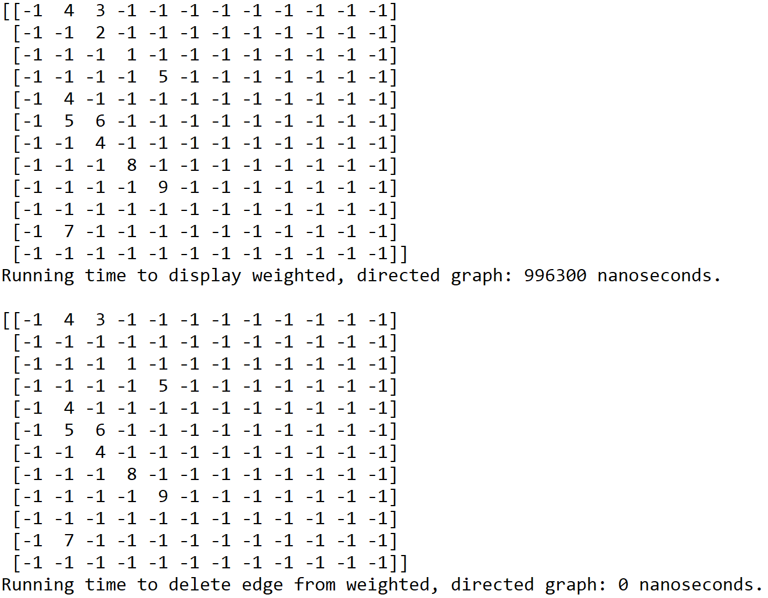

Graph representation: Edge list; Size of graph: 12 vertices

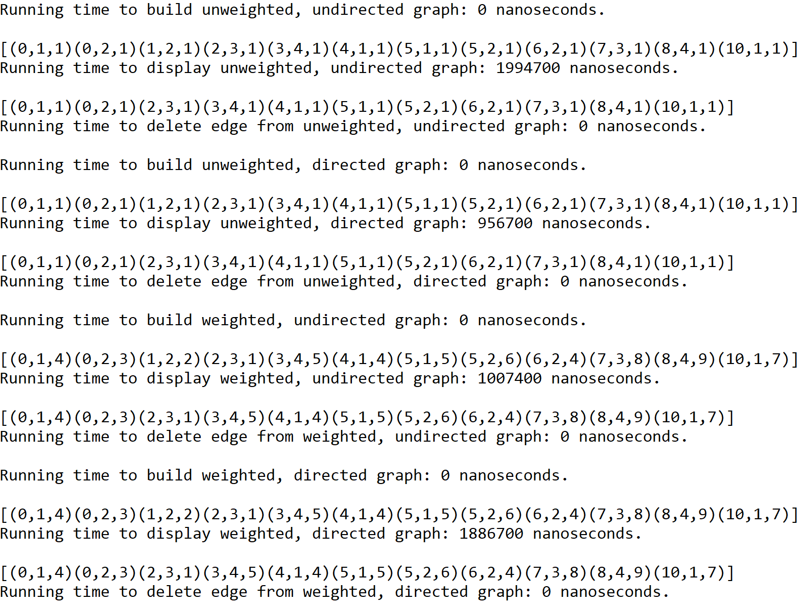

Graph representation: Adjacency list; Size of graph: 18 vertices

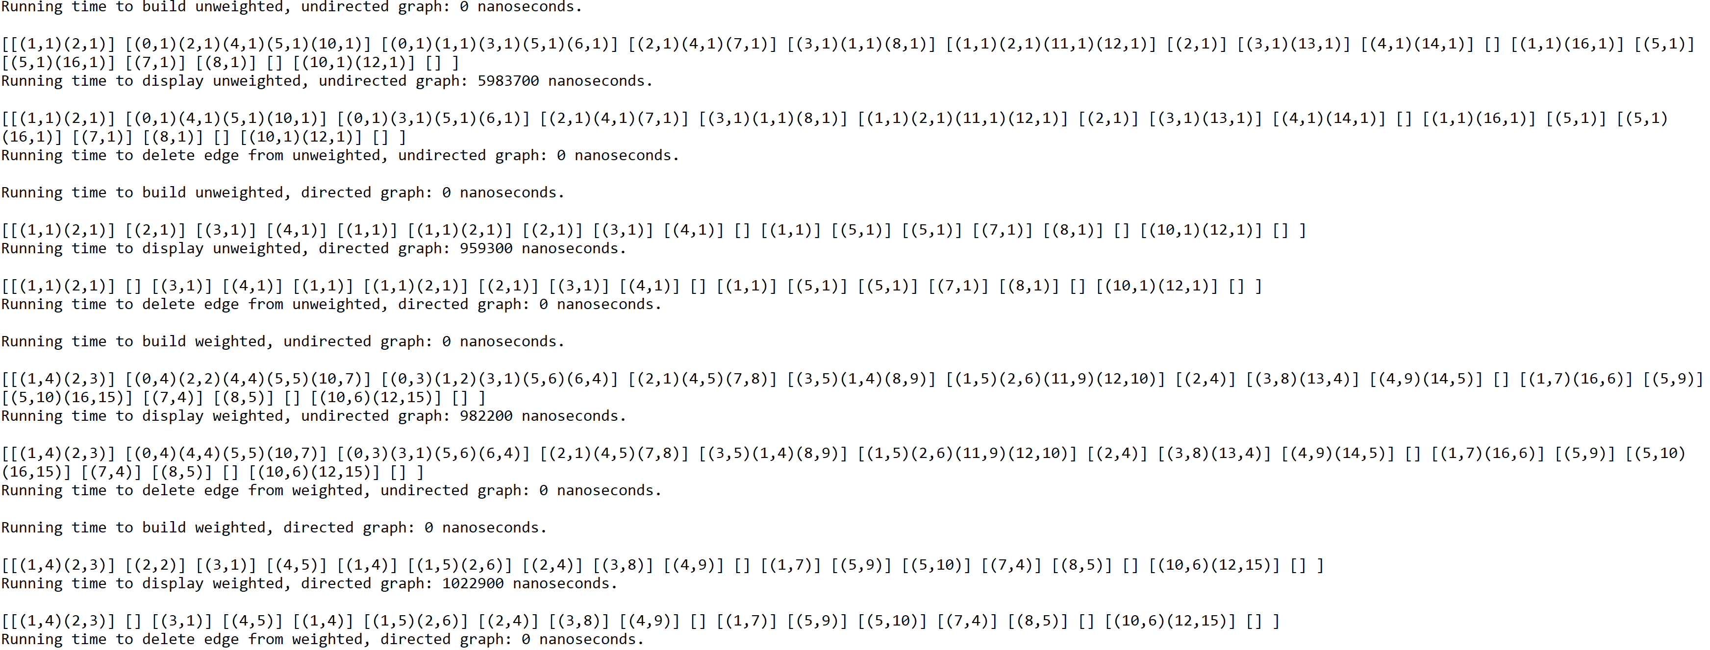

Graph representation: Adjacency matrix; Size of graph: 18 vertices

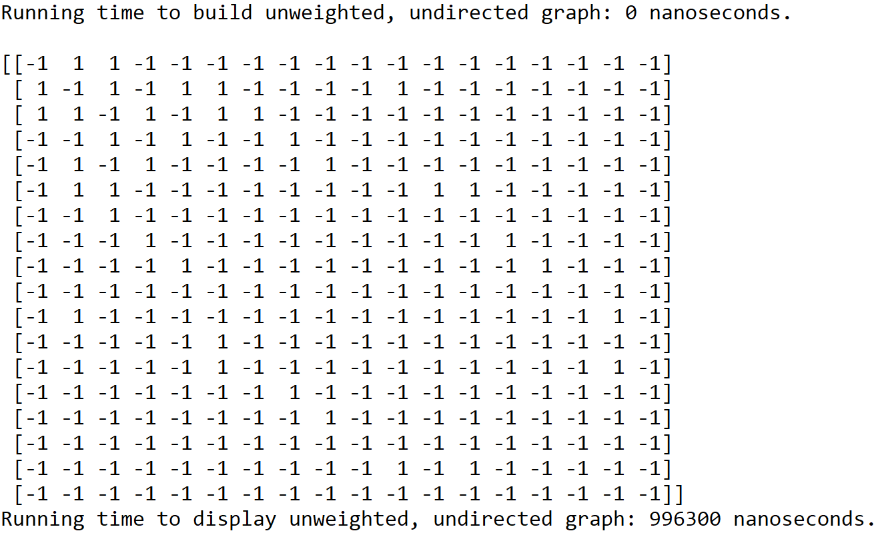

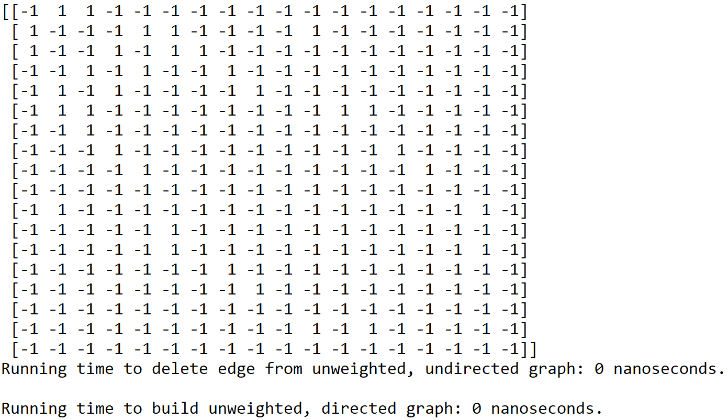

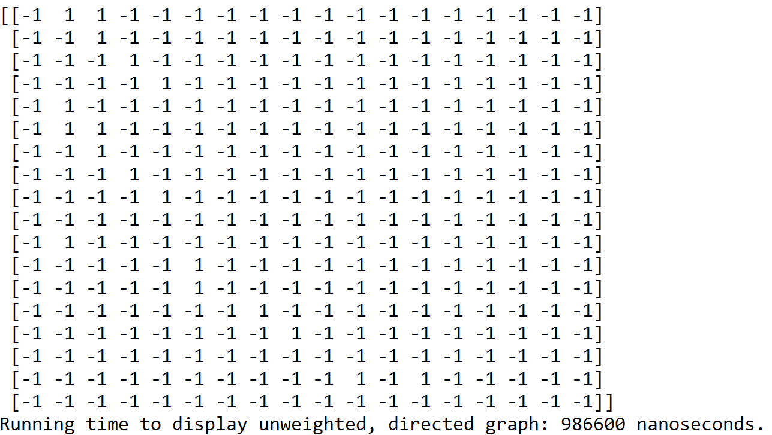

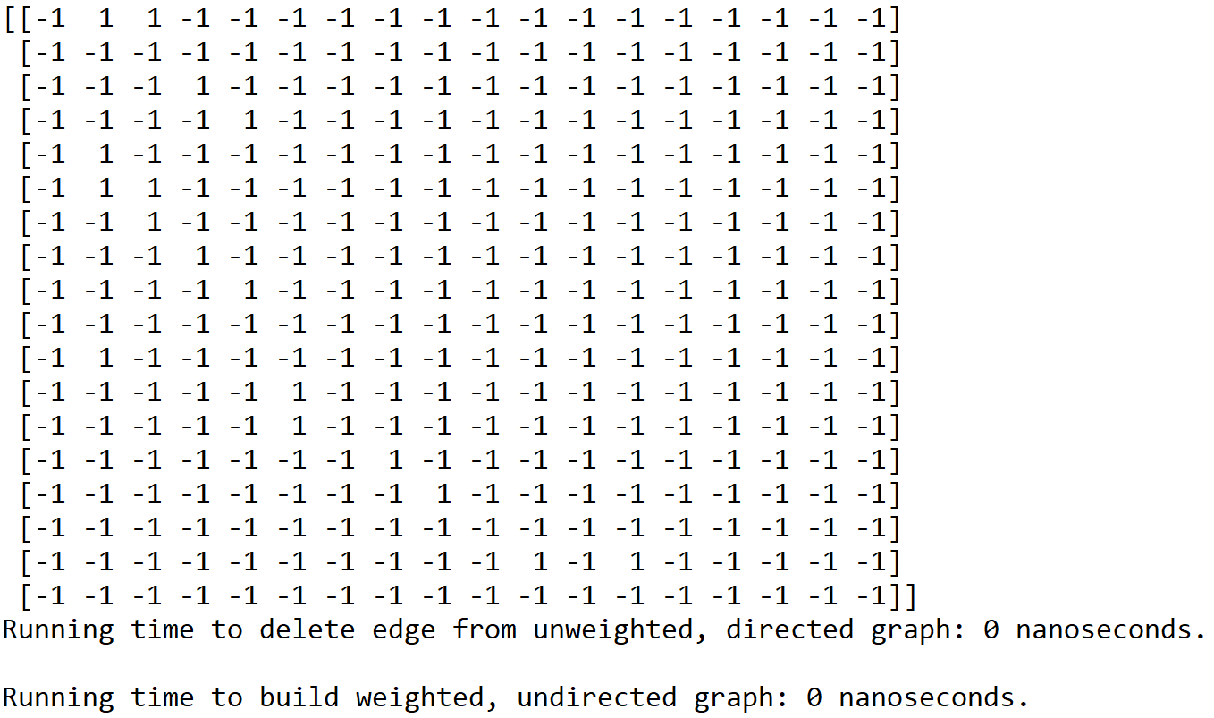

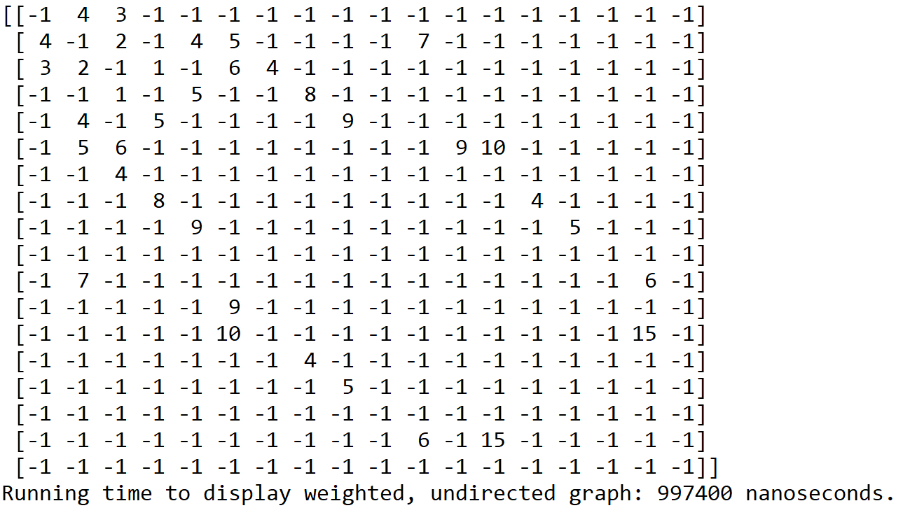

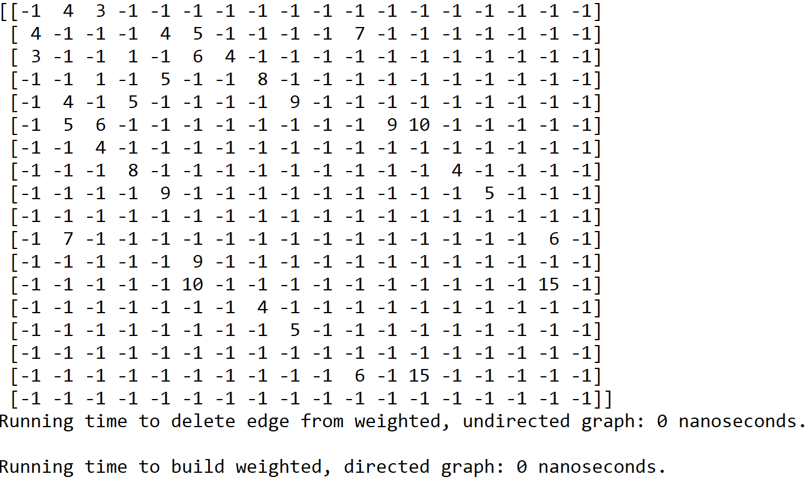

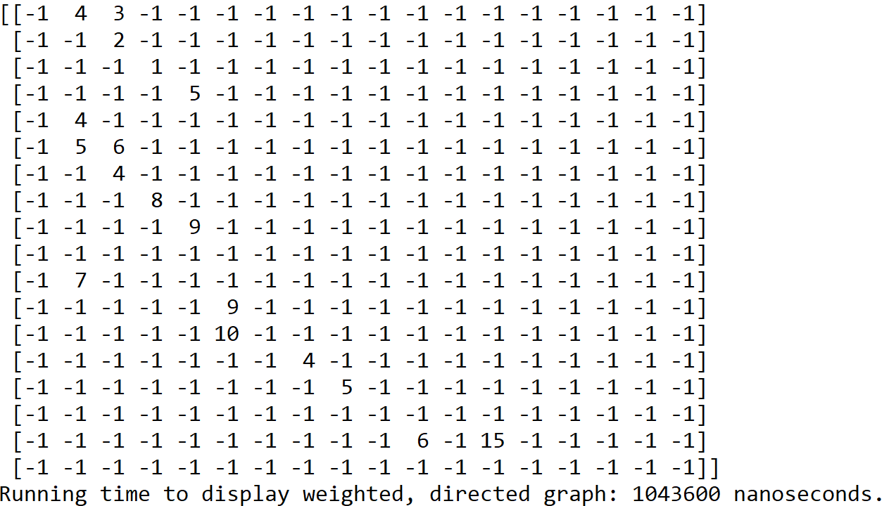

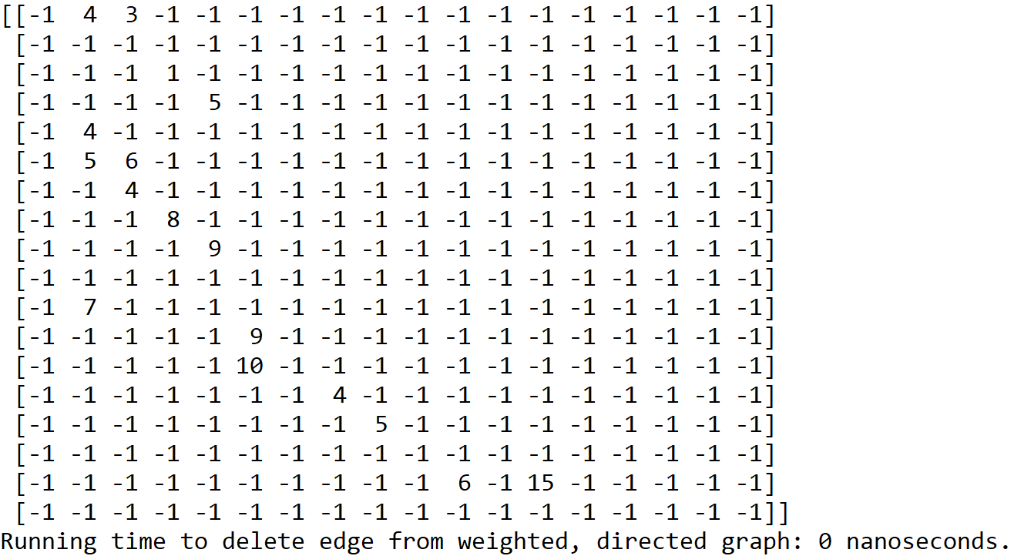

Graph representation: Edge list; Size of graph: 18 vertices

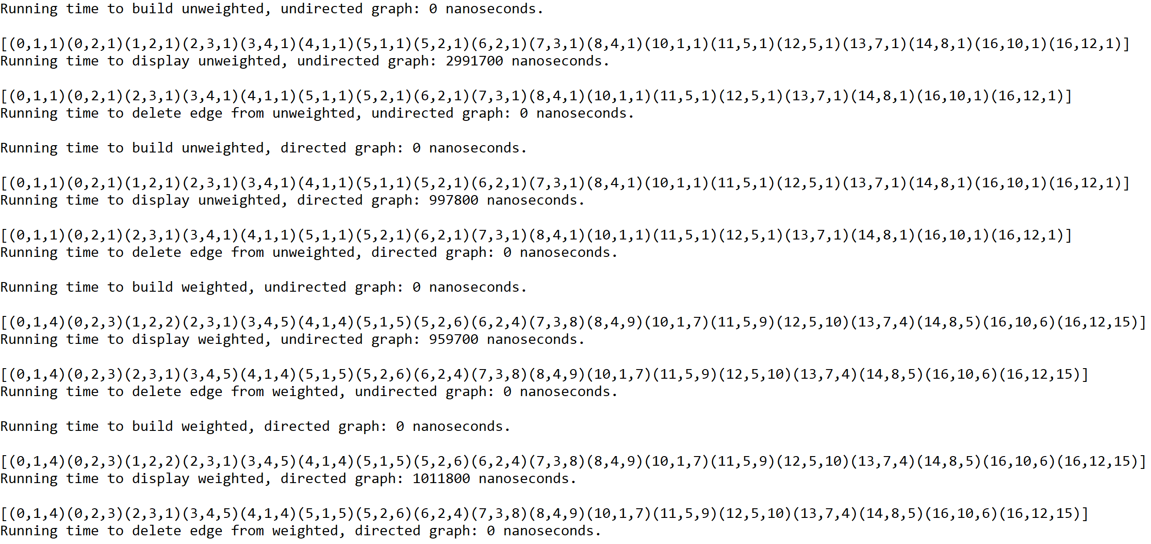

Graphs built to represent the different types of graphs and their operations

Type of graph: Unweighted, undirected; Size of graph: 6 vertices

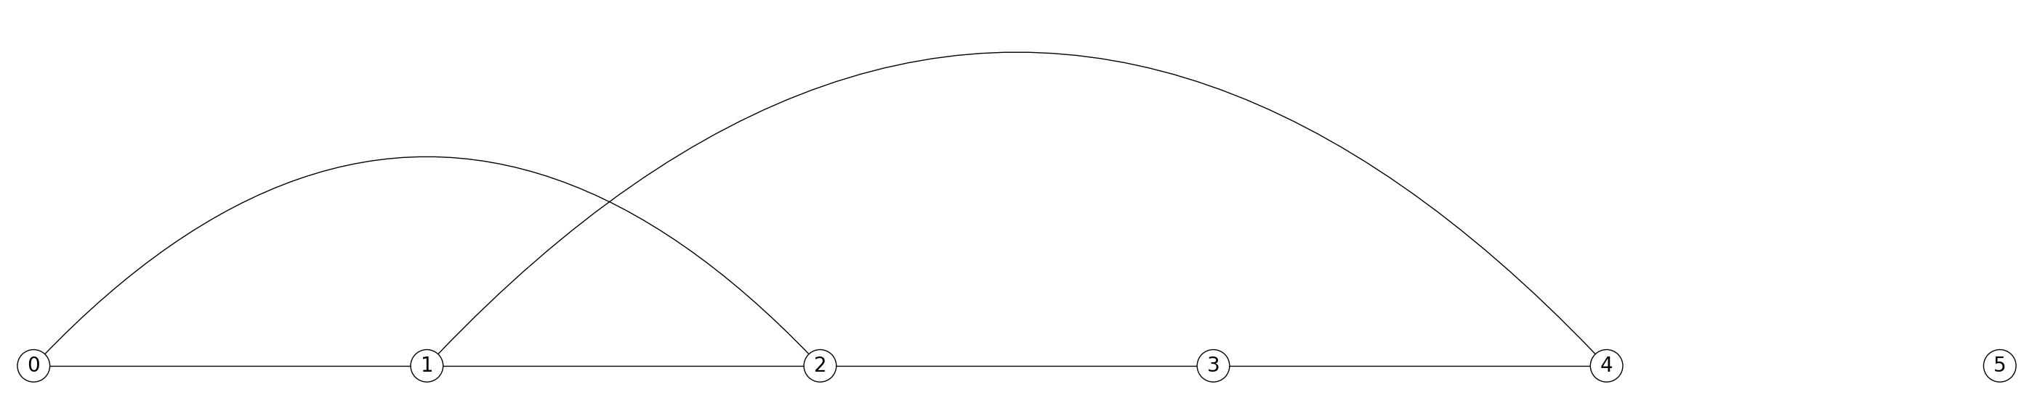

Type of graph: Unweighted, undirected; Size of graph: 6 vertices (after edge deletion)

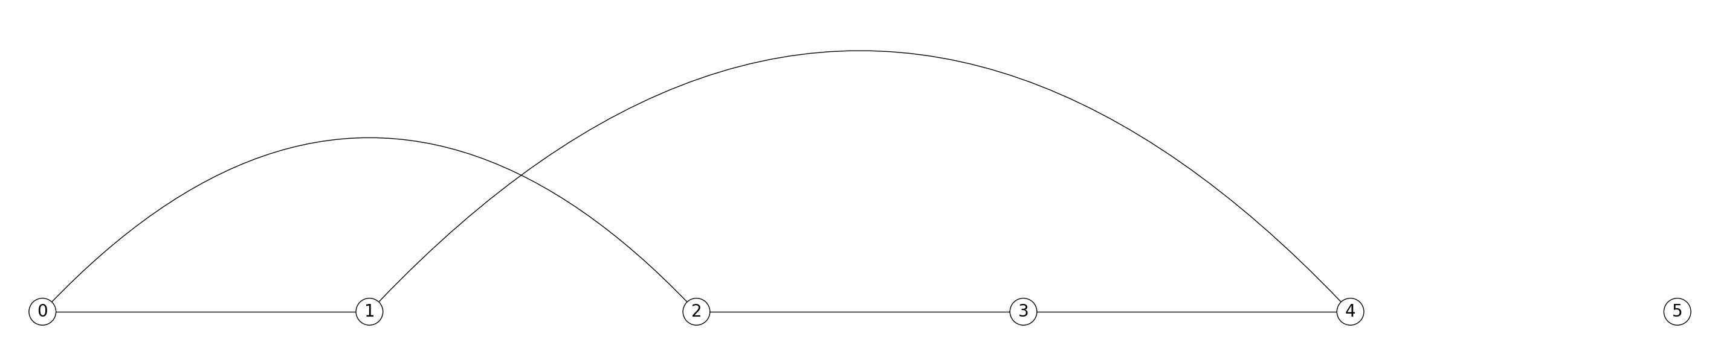

Type of graph: Unweighted, undirected; Size of graph: 12 vertices

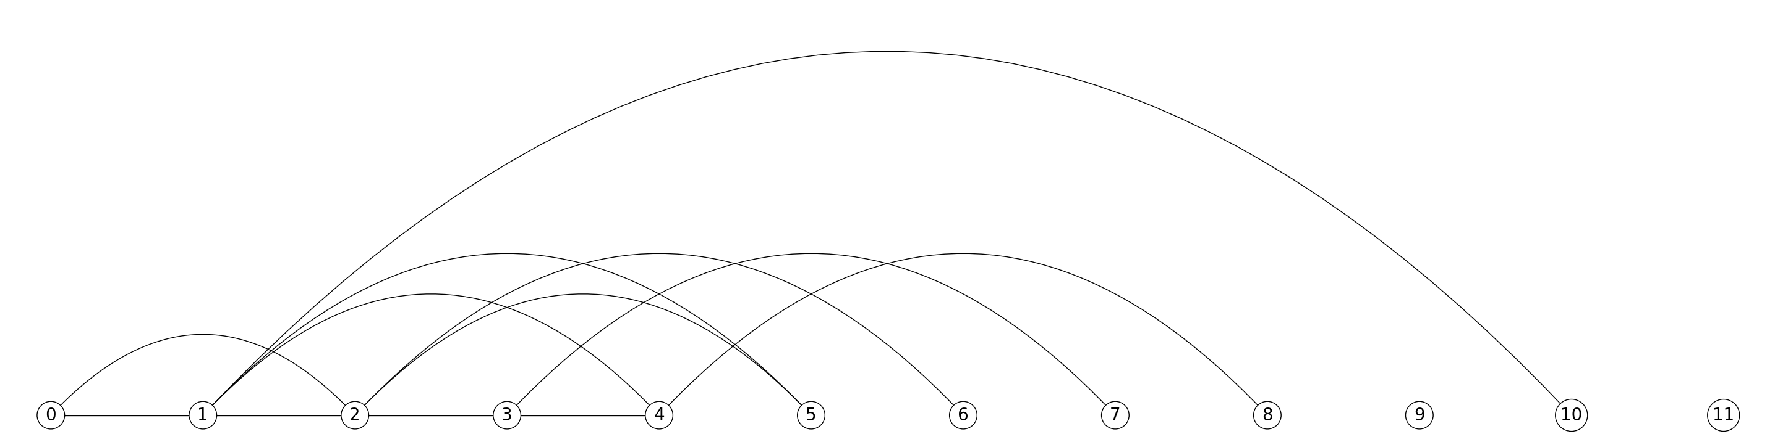

Type of graph: Unweighted, undirected; Size of graph: 12 vertices (after edge deletion)

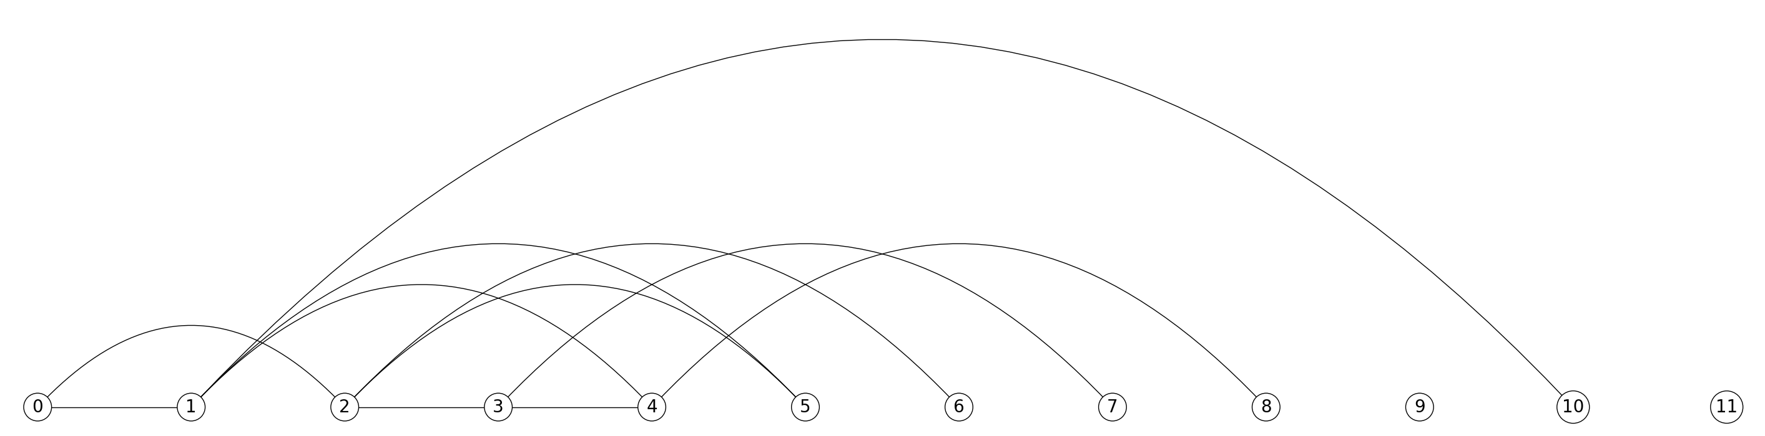

Type of graph: Unweighted, undirected; Size of graph: 18 vertices

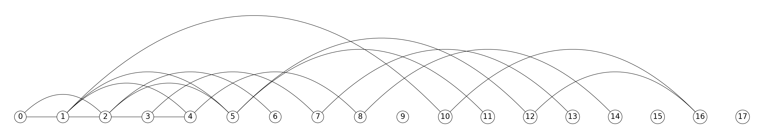

Type of graph: Unweighted, undirected; Size of graph: 18 vertices (after edge deletion)

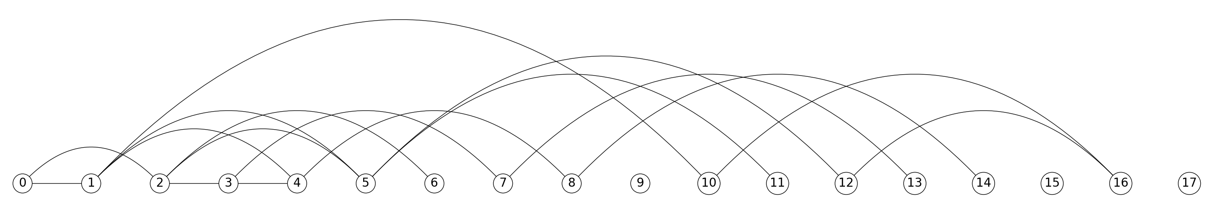

Type of graph: Unweighted, directed; Size of graph: 6 vertices

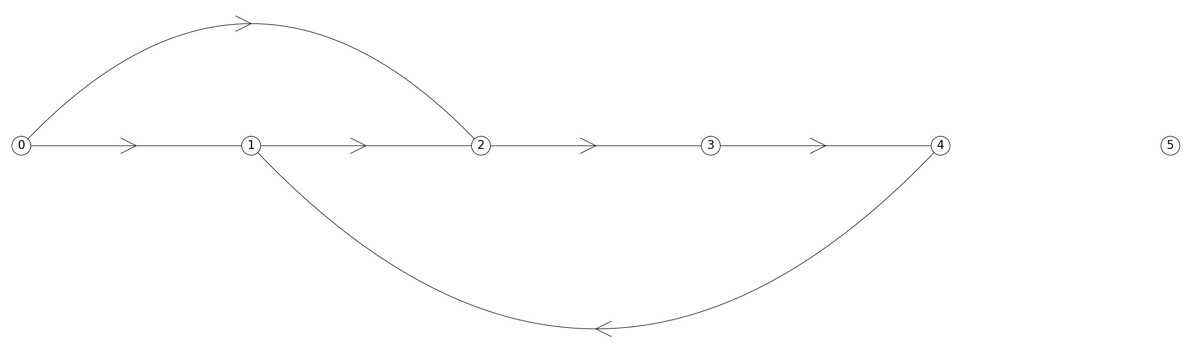

Type of graph: Unweighted, directed; Size of graph: 6 vertices (after edge deletion)

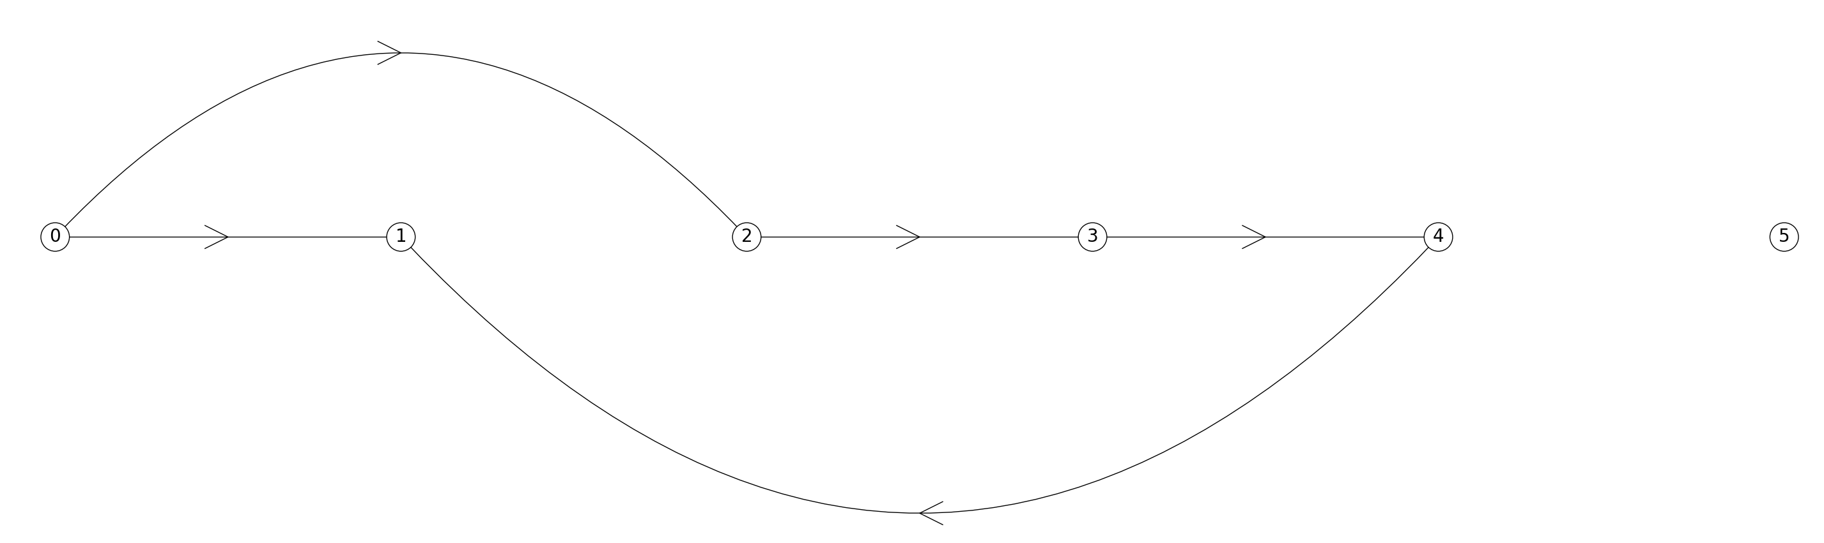

Type of graph: Unweighted, directed; Size of graph: 12 vertices

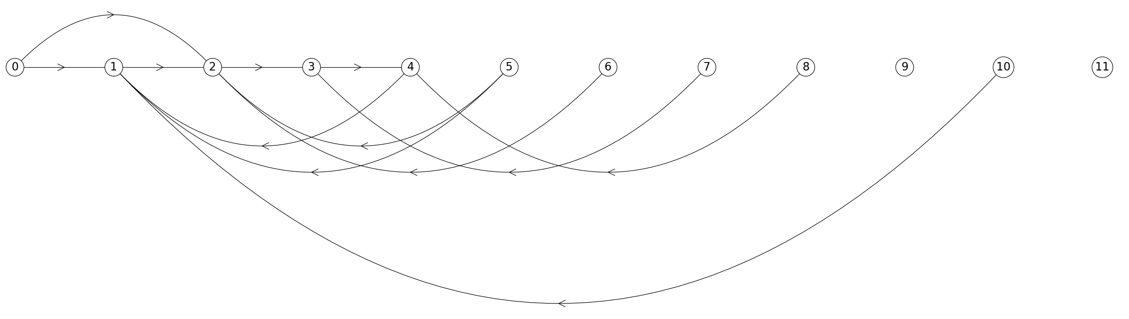

Type of graph: Unweighted, directed; Size of graph: 12 vertices (after edge deletion)

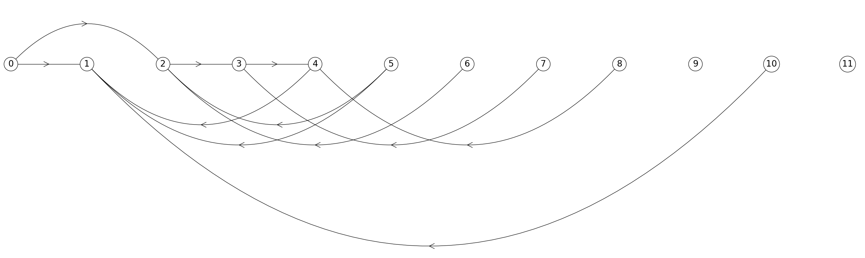

Type of graph: Unweighted, directed; Size of graph: 18 vertices

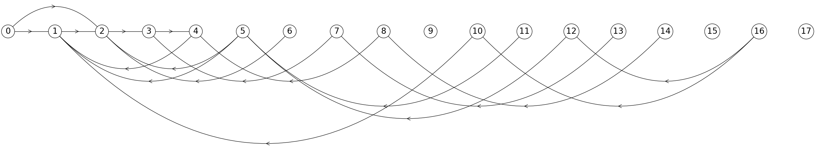

Type of graph: Unweighted, directed; Size of graph: 18 vertices (after edge deletion)

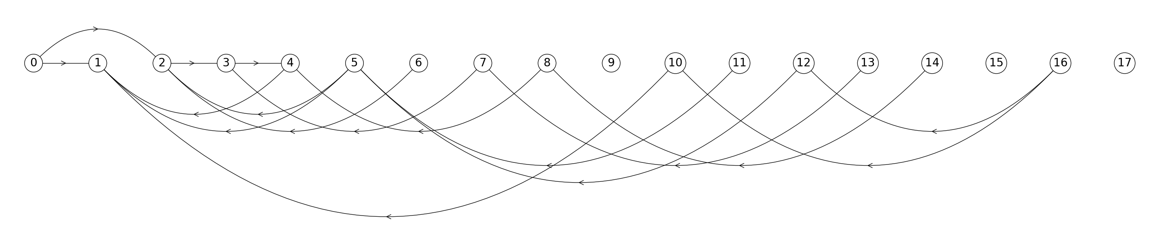

Type of graph: Weighted, undirected; Size of graph: 6 vertices

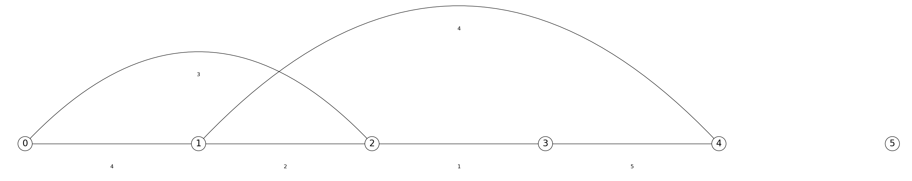

Type of graph: Weighted, undirected; Size of graph: 6 vertices (after edge deletion)

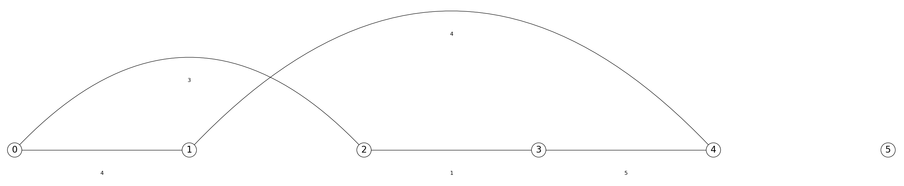

Type of graph: Weighted, undirected; Size of graph: 12 vertices

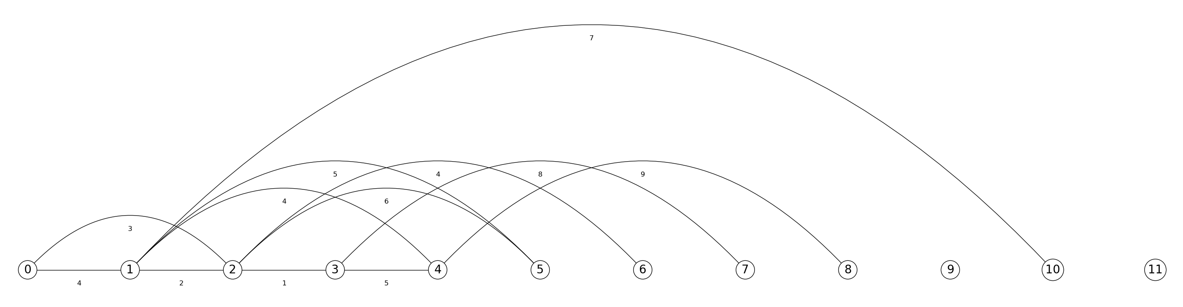

Type of graph: Weighted, undirected; Size of graph: 12 vertices (after edge deletion)

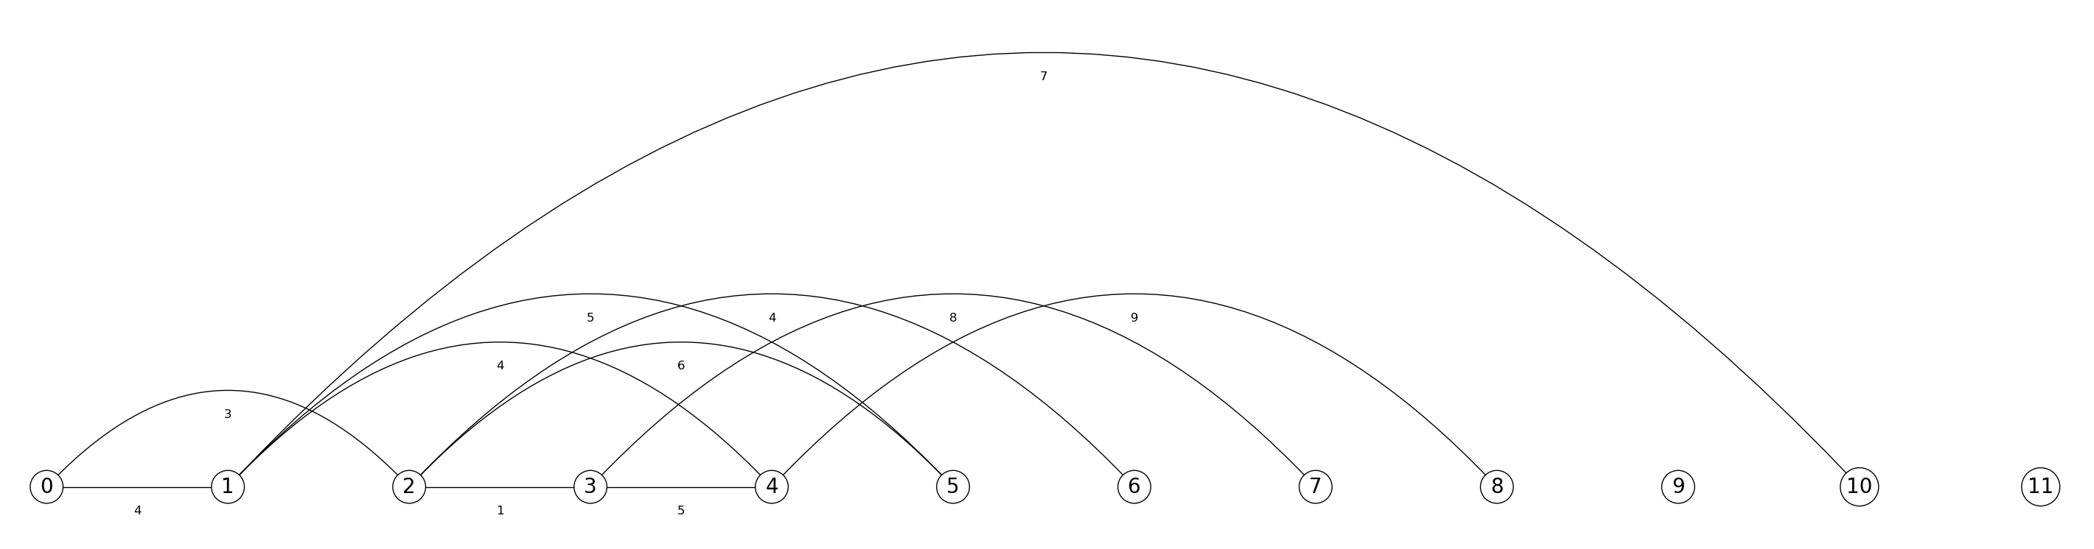

Type of graph: Weighted, undirected; Size of graph: 18 vertices

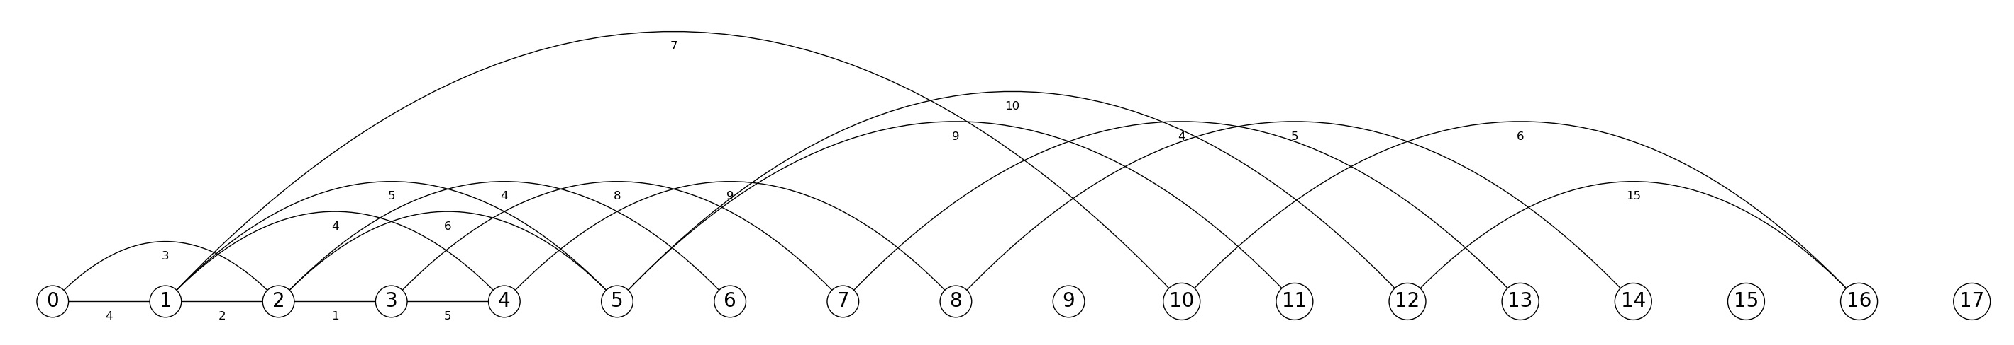

Type of graph: Weighted, undirected; Size of graph: 18 vertices (after edge deletion)

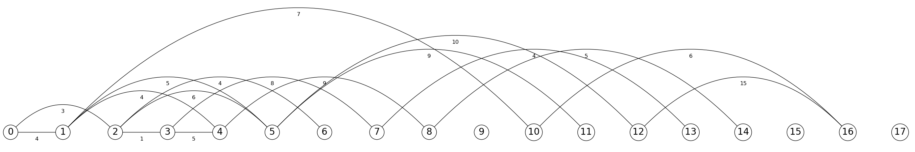

Type of graph: Weighted, directed; Size of graph: 6 vertices

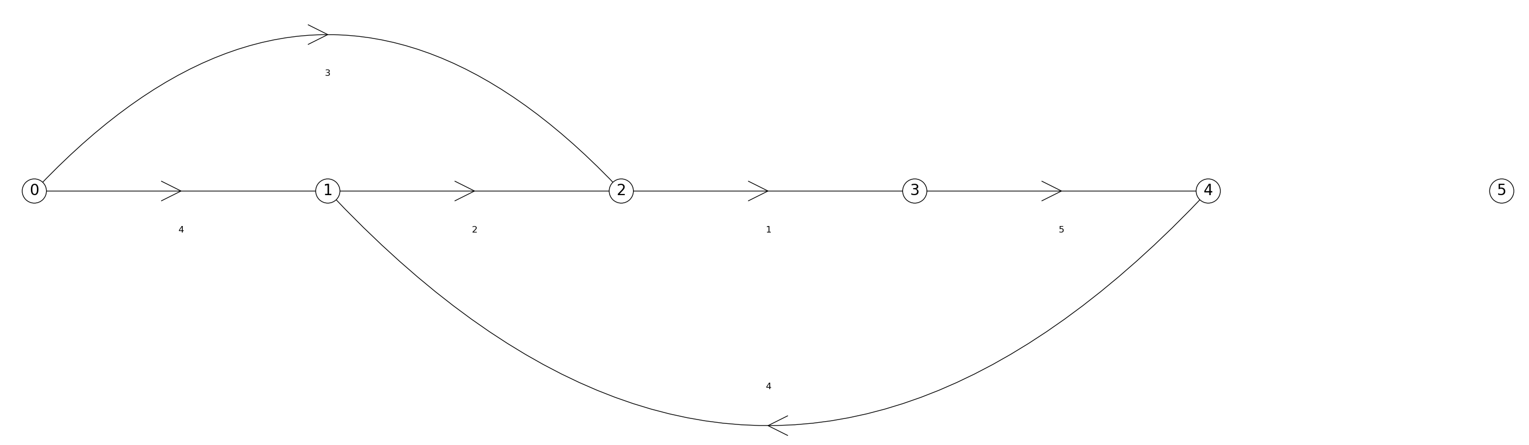

Type of graph: Weighted, directed; Size of graph: 6 vertices (after edge deletion)

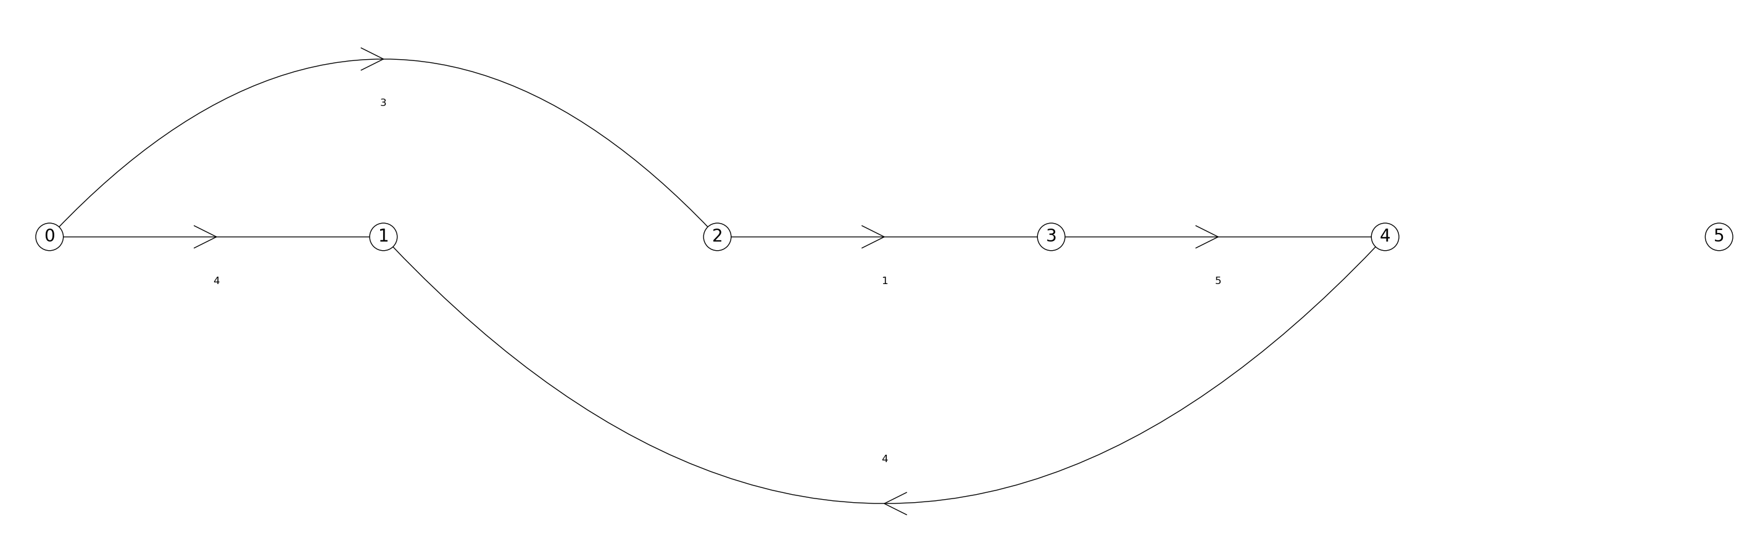

Type of graph: Weighted, directed; Size of graph: 12 vertices

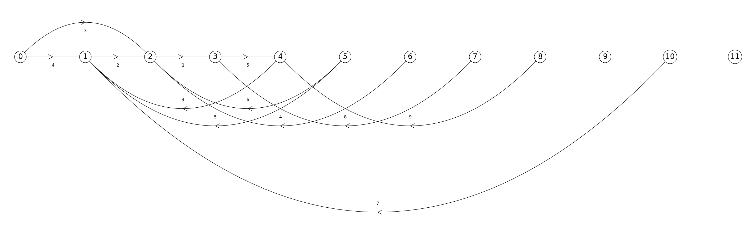

Type of graph: Weighted, directed; Size of graph: 12 vertices (after edge deletion)

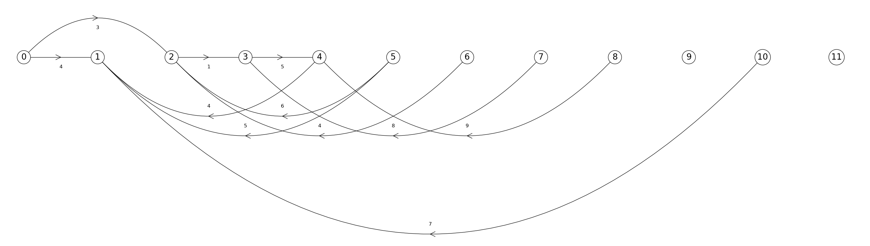

Type of graph: Weighted, directed; Size of graph: 18 vertices

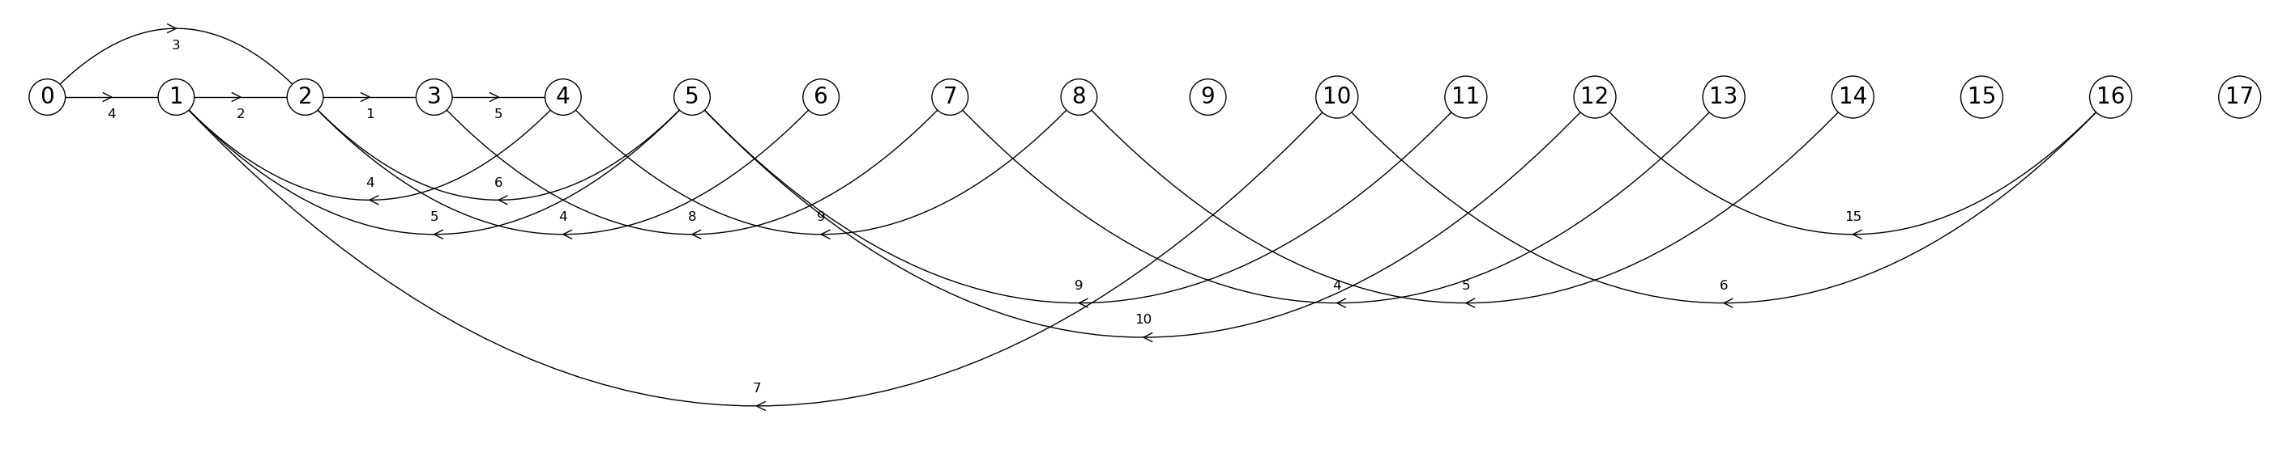

Type of graph: Weighted, directed; Size of graph: 18 vertices (after edge deletion)

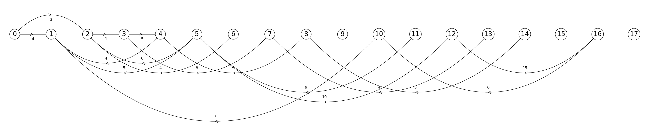

**Graphs of running times for performance of *insert_edge(), display(),* and *delete_edge()* across different graph representations**

N = Size of graph(6, 12, 18)

|  |  |  |  |
| --- | --- | --- | --- |
|  | 6 vertices | 12 vertices | 18 vertices |
| Adjacency List | 0 | 0 | 0 |
| Adjacency Matrix | 0 | 0 | 0 |
| Edge List | 0 | 0 | 0 |

|  |  |  |  |
| --- | --- | --- | --- |
|  | 6 vertices | 12 vertices | 18 vertices |
| Adjacency List | 0 | 0 | 0 |
| Adjacency Matrix | 0 | 0 | 0 |
| Edge List | 0 | 0 | 0 |

|  |  |  |  |
| --- | --- | --- | --- |
|  | 6 vertices | 12 vertices | 18 vertices |
| Adjacency List | 0 | 0 | 0 |
| Adjacency Matrix | 0 | 0 | 0 |
| Edge List | 0 | 0 | 0 |

|  |  |  |  |
| --- | --- | --- | --- |
|  | 6 vertices | 12 vertices | 18 vertices |
| Adjacency List | 0 | 0 | 0 |
| Adjacency Matrix | 0 | 0 | 0 |
| Edge List | 0 | 0 | 0 |

|  |  |  |  |
| --- | --- | --- | --- |
|  | 6 vertices | 12 vertices | 18 vertices |
| Adjacency List | 1995400 | 1995200 | 5983700 |
| Adjacency Matrix | 0 | 996400 | 996300 |
| Edge List | 0 | 1994700 | 2991700 |

|  |  |  |  |
| --- | --- | --- | --- |
|  | 6 vertices | 12 vertices | 18 vertices |
| Adjacency List | 955800 | 2974100 | 959300 |
| Adjacency Matrix | 0 | 997300 | 986600 |
| Edge List | 0 | 956700 | 997800 |

|  |  |  |  |
| --- | --- | --- | --- |
|  | 6 vertices | 12 vertices | 18 vertices |
| Adjacency List | 1954800 | 2954500 | 982200 |
| Adjacency Matrix | 0 | 997200 | 997400 |
| Edge List | 0 | 1007400 | 959700 |

|  |  |  |  |
| --- | --- | --- | --- |
|  | 6 vertices | 12 vertices | 18 vertices |
| Adjacency List | 996400 | 973400 | 1022900 |
| Adjacency Matrix | 0 | 996300 | 1043600 |
| Edge List | 0 | 1886700 | 1011800 |

|  |  |  |  |
| --- | --- | --- | --- |
|  | 6 vertices | 12 vertices | 18 vertices |
| Adjacency List | 0 | 0 | 0 |
| Adjacency Matrix | 0 | 0 | 0 |
| Edge List | 0 | 0 | 0 |

|  |  |  |  |
| --- | --- | --- | --- |
|  | 6 vertices | 12 vertices | 18 vertices |
| Adjacency List | 0 | 0 | 0 |
| Adjacency Matrix | 0 | 0 | 0 |
| Edge List | 0 | 0 | 0 |

|  |  |  |  |
| --- | --- | --- | --- |
|  | 6 vertices | 12 vertices | 18 vertices |
| Adjacency List | 0 | 0 | 0 |
| Adjacency Matrix | 0 | 0 | 0 |
| Edge List | 0 | 0 | 0 |

|  |  |  |  |
| --- | --- | --- | --- |
|  | 6 vertices | 12 vertices | 18 vertices |
| Adjacency List | 0 | 0 | 0 |
| Adjacency Matrix | 0 | 0 | 0 |
| Edge List | 0 | 0 | 0 |

**Part 2**

In this part, I will build a graph that contains all 16 vertices representing the possible states of the riddle and the edges representing legal transitions between legal states. Additionally, I will call the corresponding breadth-first search and depth-first search algorithms to build the paths that will be used to build the graphs that contain the solutions to the riddle.

Graph representation: Adjacency list

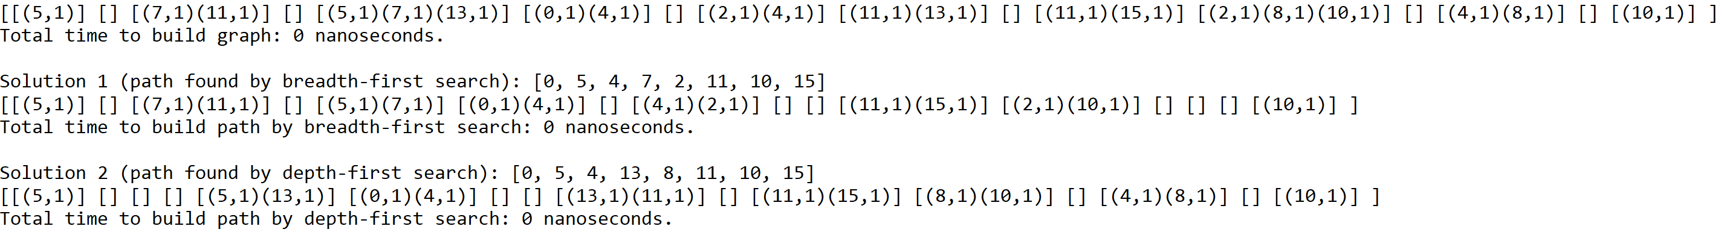

Graph representation: Adjacency matrix

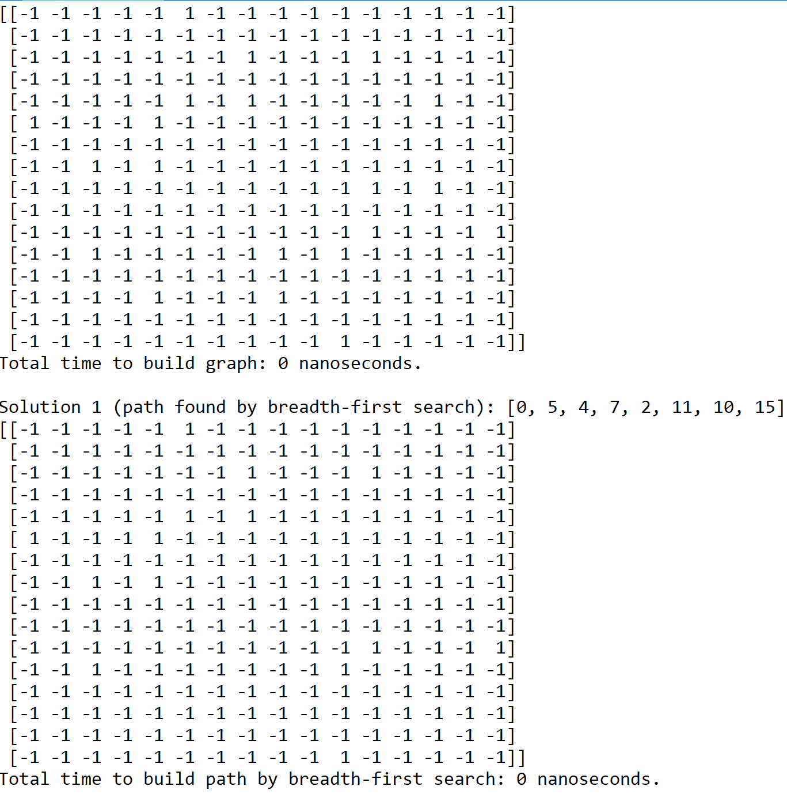



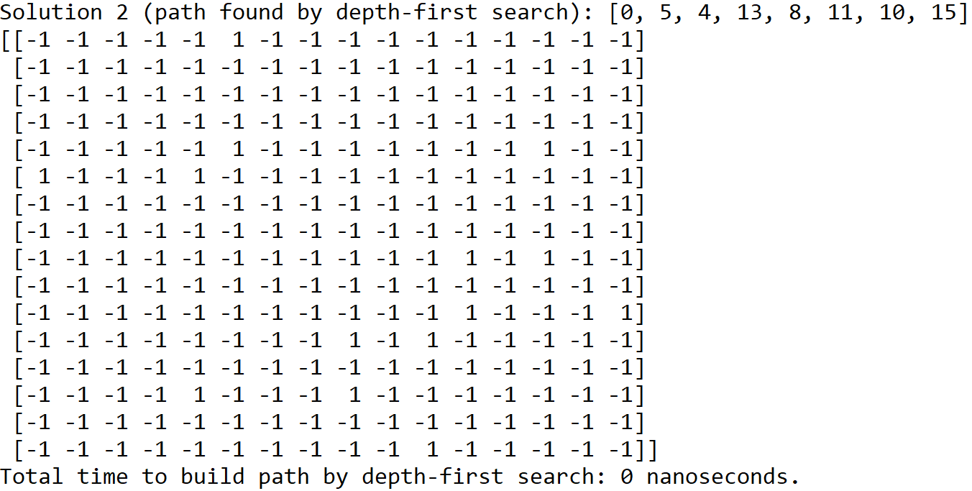

Graph representation: Edge list

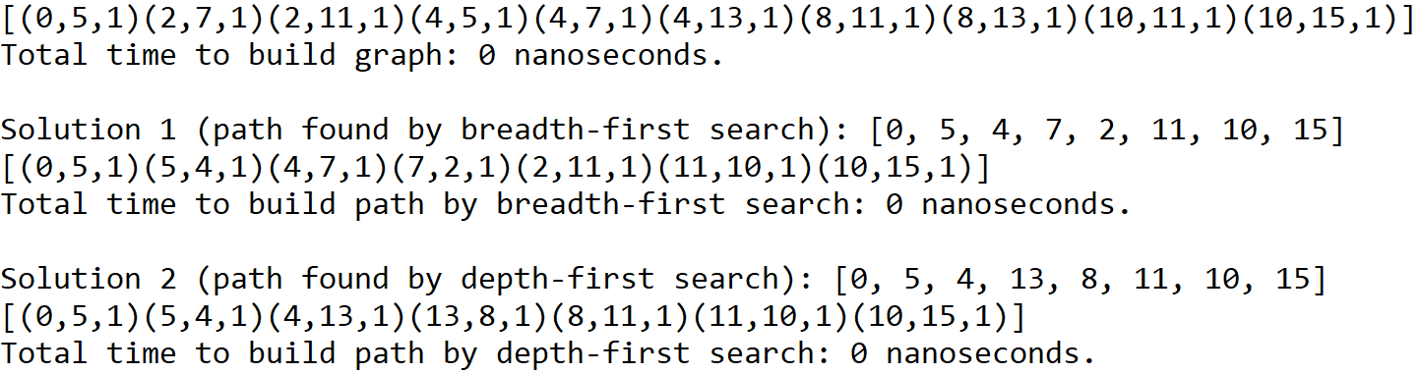

Graphs built to represent the riddle and its solutions

Graph representation of the riddle

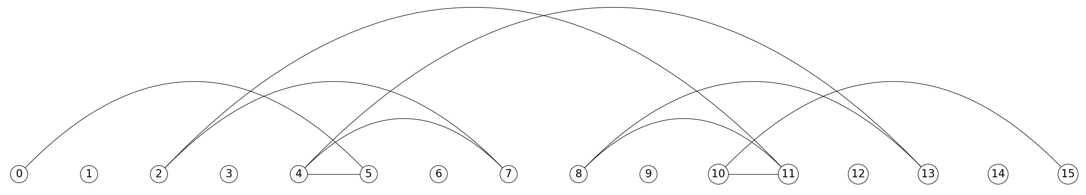

Graph representation of the solution to the riddle obtained by breadth-first search

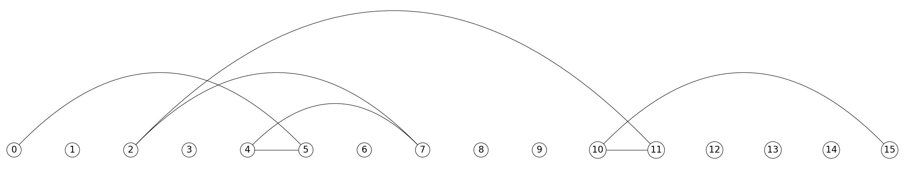

Graph representation of the solution to the riddle obtained by depth-first search

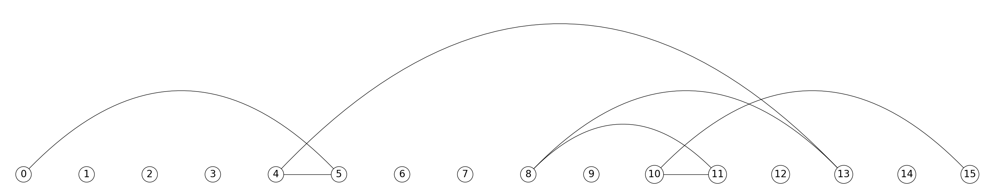

In Part 1, the results show that the *display()* function is the only function that yields meaningful running times across all three graph representations. The *insert_edge()* and *delete_edge()* functions yield running times of 0 nanoseconds across all three graph representations. This could be attributed to several factors. For example, the *insert_edge()* function of all three graph representations takes constant time to insert an edge between the source and destination vertices because it does not need to traverse through the graph in order to insert such an edge. Instead, it immediately accesses the source vertex in the graph in order to establish a connection between that vertex and the destination vertex.

In the case of the *delete_edge()* function, the adjacency list and edge list representations of the graph need to traverse through their respective list in order to find the edge to be deleted while the adjacency matrix representation of the graph only needs to access the indices of the source and destination vertices in order set the value at that position to -1, which means that those two vertices are not connected by an edge. However, it is possible that the edge given to these three representations being close to the beginning of the graph could be the main factor that yielded these running times of 0 nanoseconds across all three graph representations. In order to yield meaningful running times for the *delete_edge()* function, an edge shared by all three graph representations that is close to the end of the graph would allow the function in each graph representation to take its time in locating and deleting said edge.

For the *display()* function, the adjacency matrix representation of the unweighted and undirected graph took the least amount of time to display the graph to the terminal. While the results of this function for the unweighted and directed and the weighted and undirected graphs look similar, they both show that the adjacency matrix and edge list representations of these graph took less time than the adjacency list representation to display the graph to the terminal. From these results, it can be determined that the *display()* function of the adjacency matrix representation of the graph is more efficient than the other two *display()* functions because unlike those functions, it does not need to traverse through the entire representation to display it to the terminal as it only needs to print the adjacency matrix itself.

In Part 2, the results show that each of the two possible solutions to the riddle can be found by each search algorithm. Furthermore, the first three vertices (0, 5, 4) and the last three vertices (11, 10, 15) are traversed in that order in both paths produced by each search algorithm while the middle two vertices vary between both paths. It should be noted that the breadth-first search algorithm found its solution to the riddle by visiting all vertices of consecutive distances from the starting vertex without revisiting a vertex, and the depth-first search algorithm found its solution by visiting every vertex along each path from the starting vertex to the end of the path before backtracking. Due to the nature of the search algorithms and the shape of the original graph, it is possible that there are vertices that are visited by both search algorithms in the same order.

**Conclusion**

This lab helped me understand adjacency list, adjacency matrix, and edge list graph representations better by allowing me to use their respective properties to construct various types of functions. For example, the adjacency list graph representation takes advantage of the fact that the indices of the lists inside the adjacency list itself represent the vertices of the graph while the contents of the inner lists represent the edges between vertices. In the case of the adjacency matrix, the vertices of the graph are represented by the indices of the rows and columns of the adjacency matrix, and the edges between vertices are represented by the value of the element at a given position dictated by the row and column indices, which indicate the source and destination vertices, respectively. In the case of the edge list, the vertices of the graph are represented as elements of the edge list, and the edges between vertices are represented by total number of elements in the edge list. With these properties in mind, I was able to interpret and implement the same functions for all three graph representations.

Additionally, this lab helped me understand breadth-first search and depth-first search better by allowing me to traverse through the graph and trace every step each search algorithm takes in order to find a specific path from one vertex to another one. For example, the breadth-first search algorithm visits every vertex of consecutive distance from the starting vertex without revisiting a vertex. In the case of the depth-first search algorithm, it visits every vertex along each path from the starting vertex to the end of the path before backtracking to a previous vertex. Once I understood the way in which each search algorithm visits every vertex of the graph, I was able to interpret the fox, chicken, and grain riddle as a graph.

**Appendix**

graph_AL.py

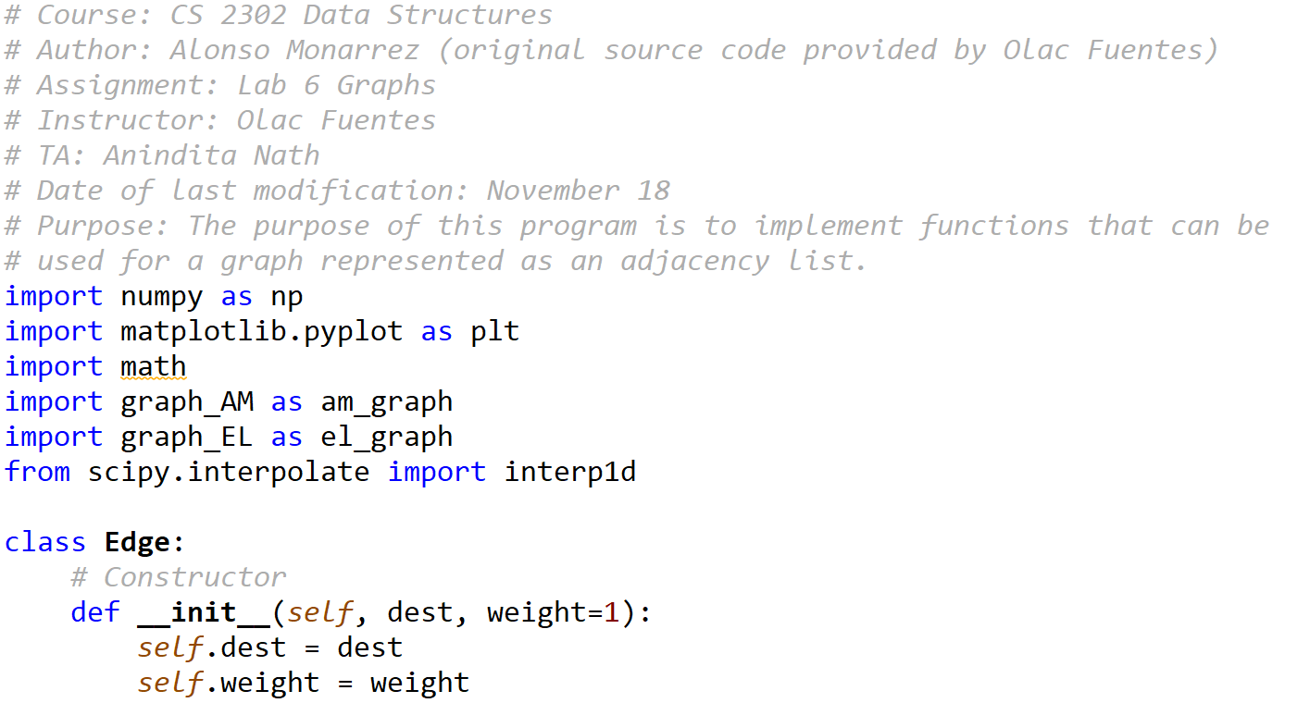

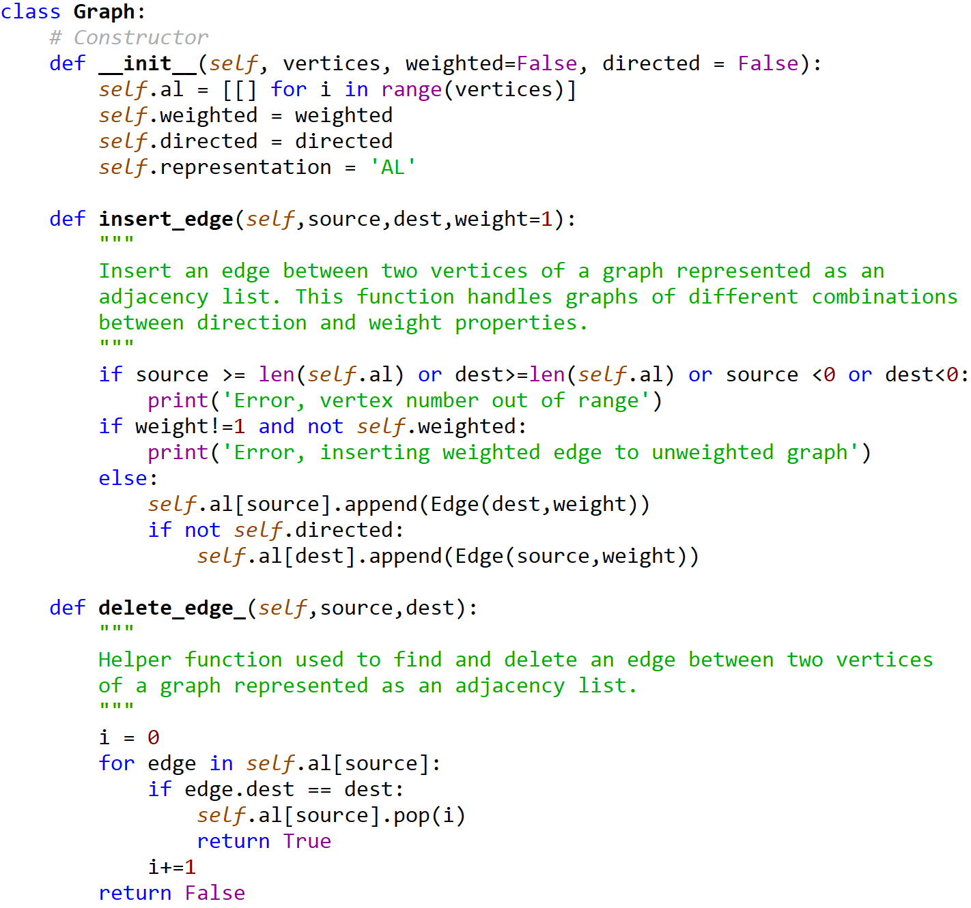

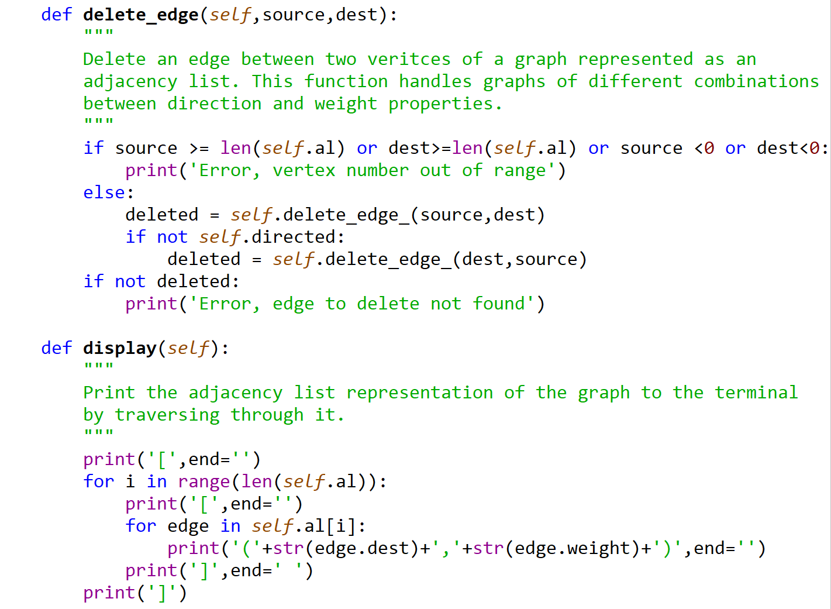

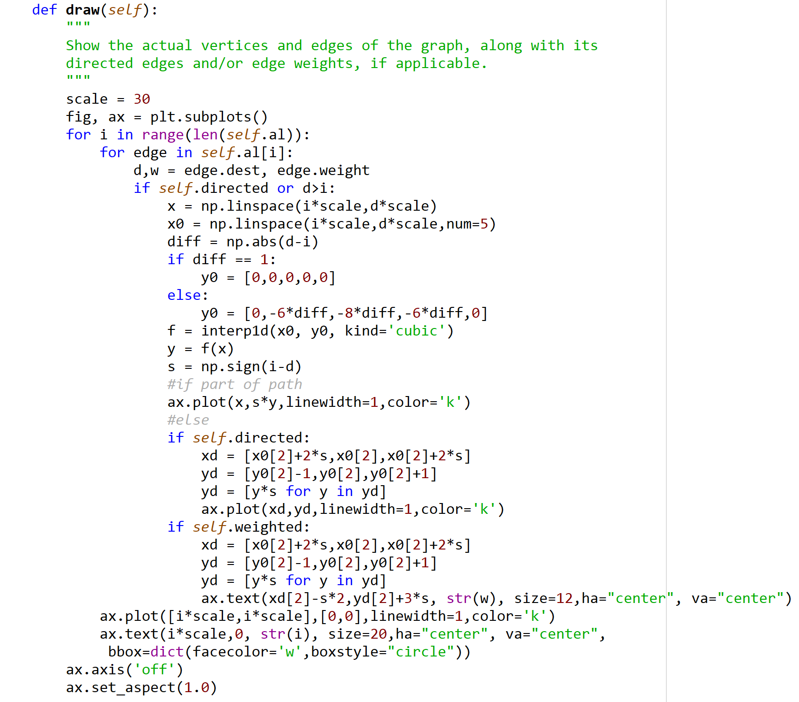

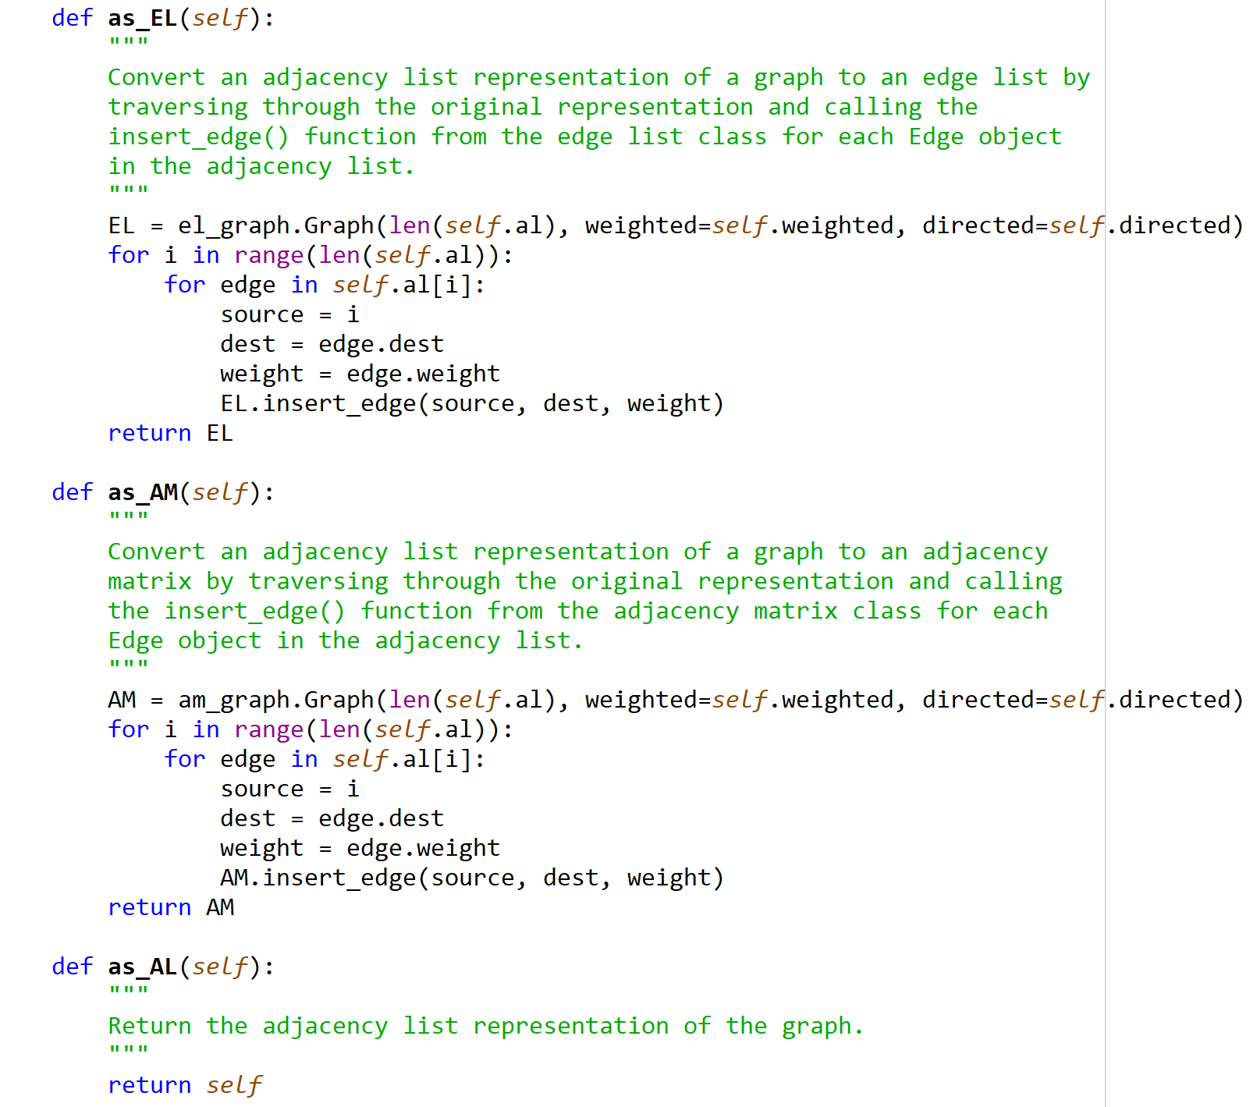

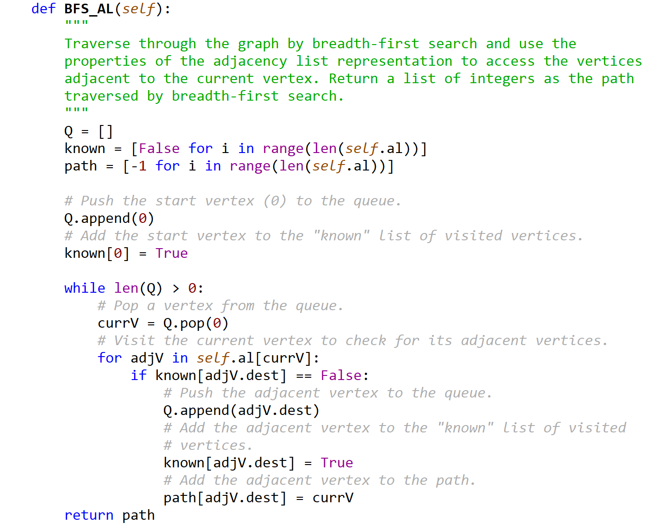

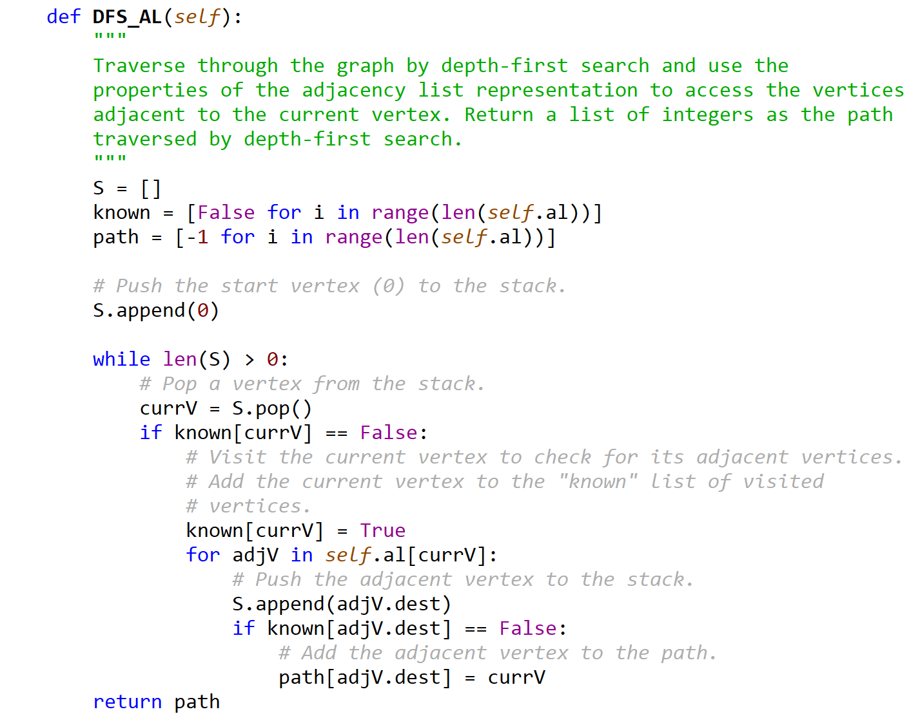

graph_AM.py

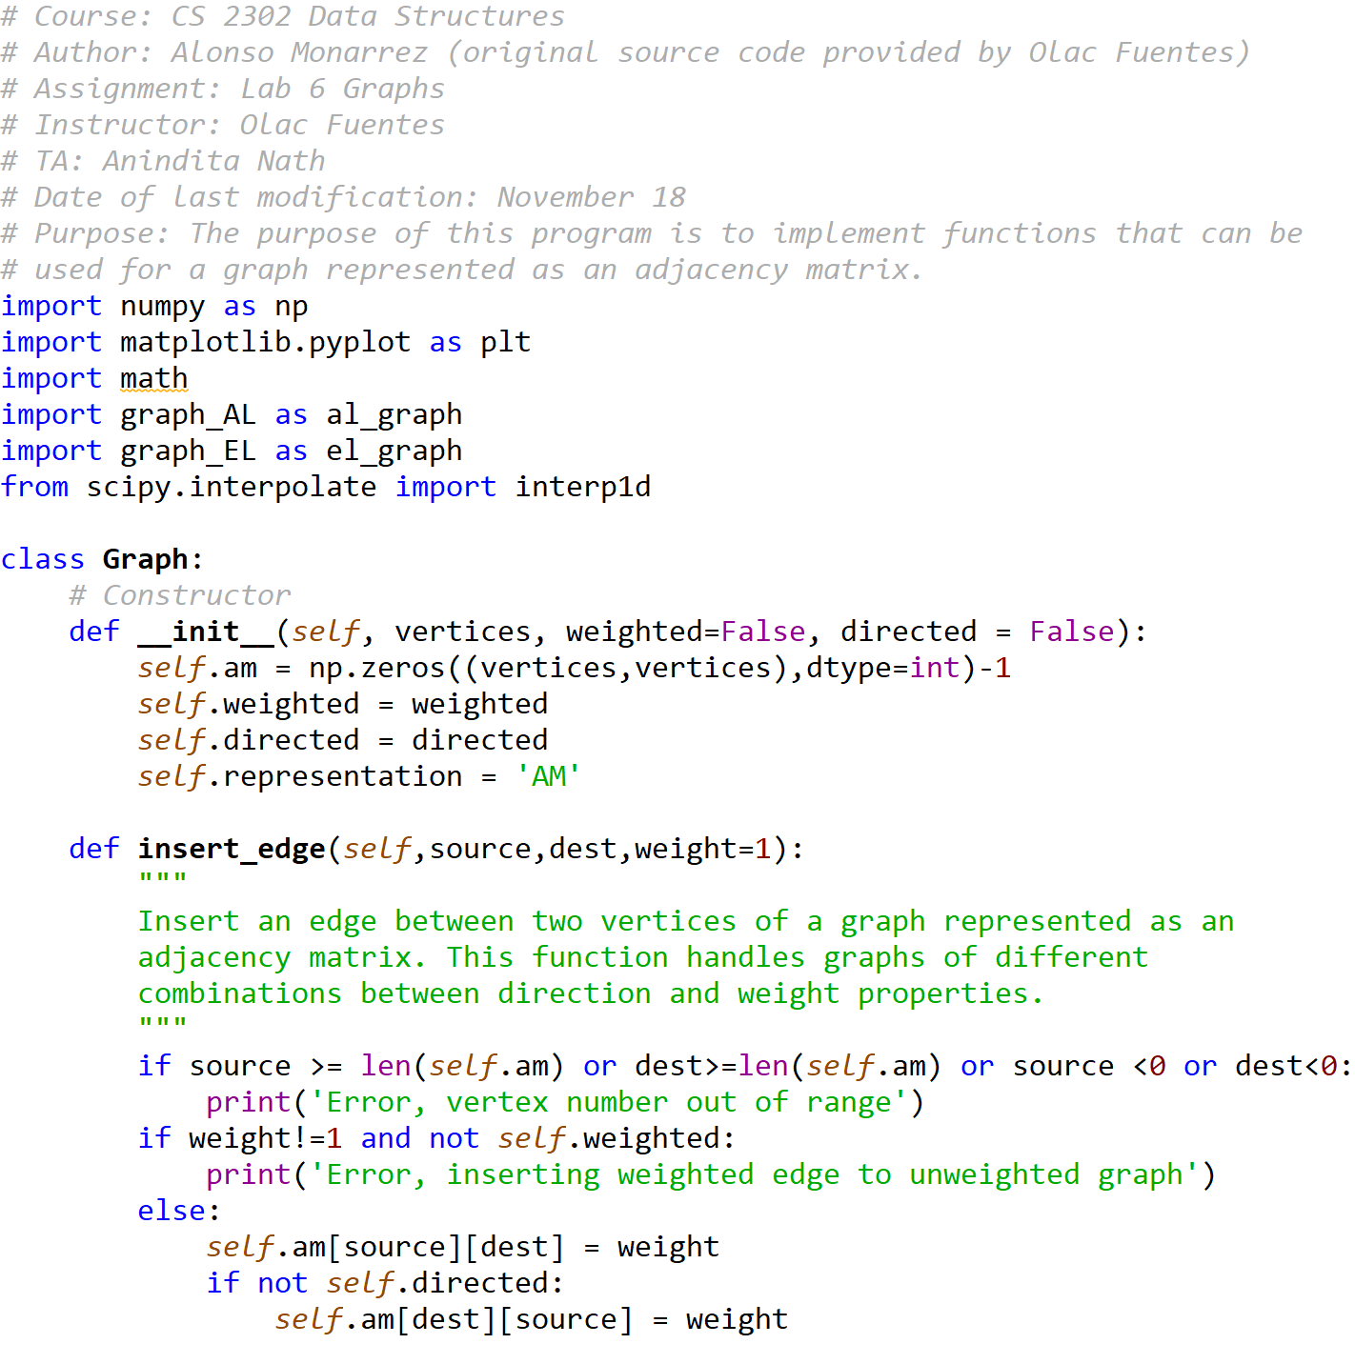

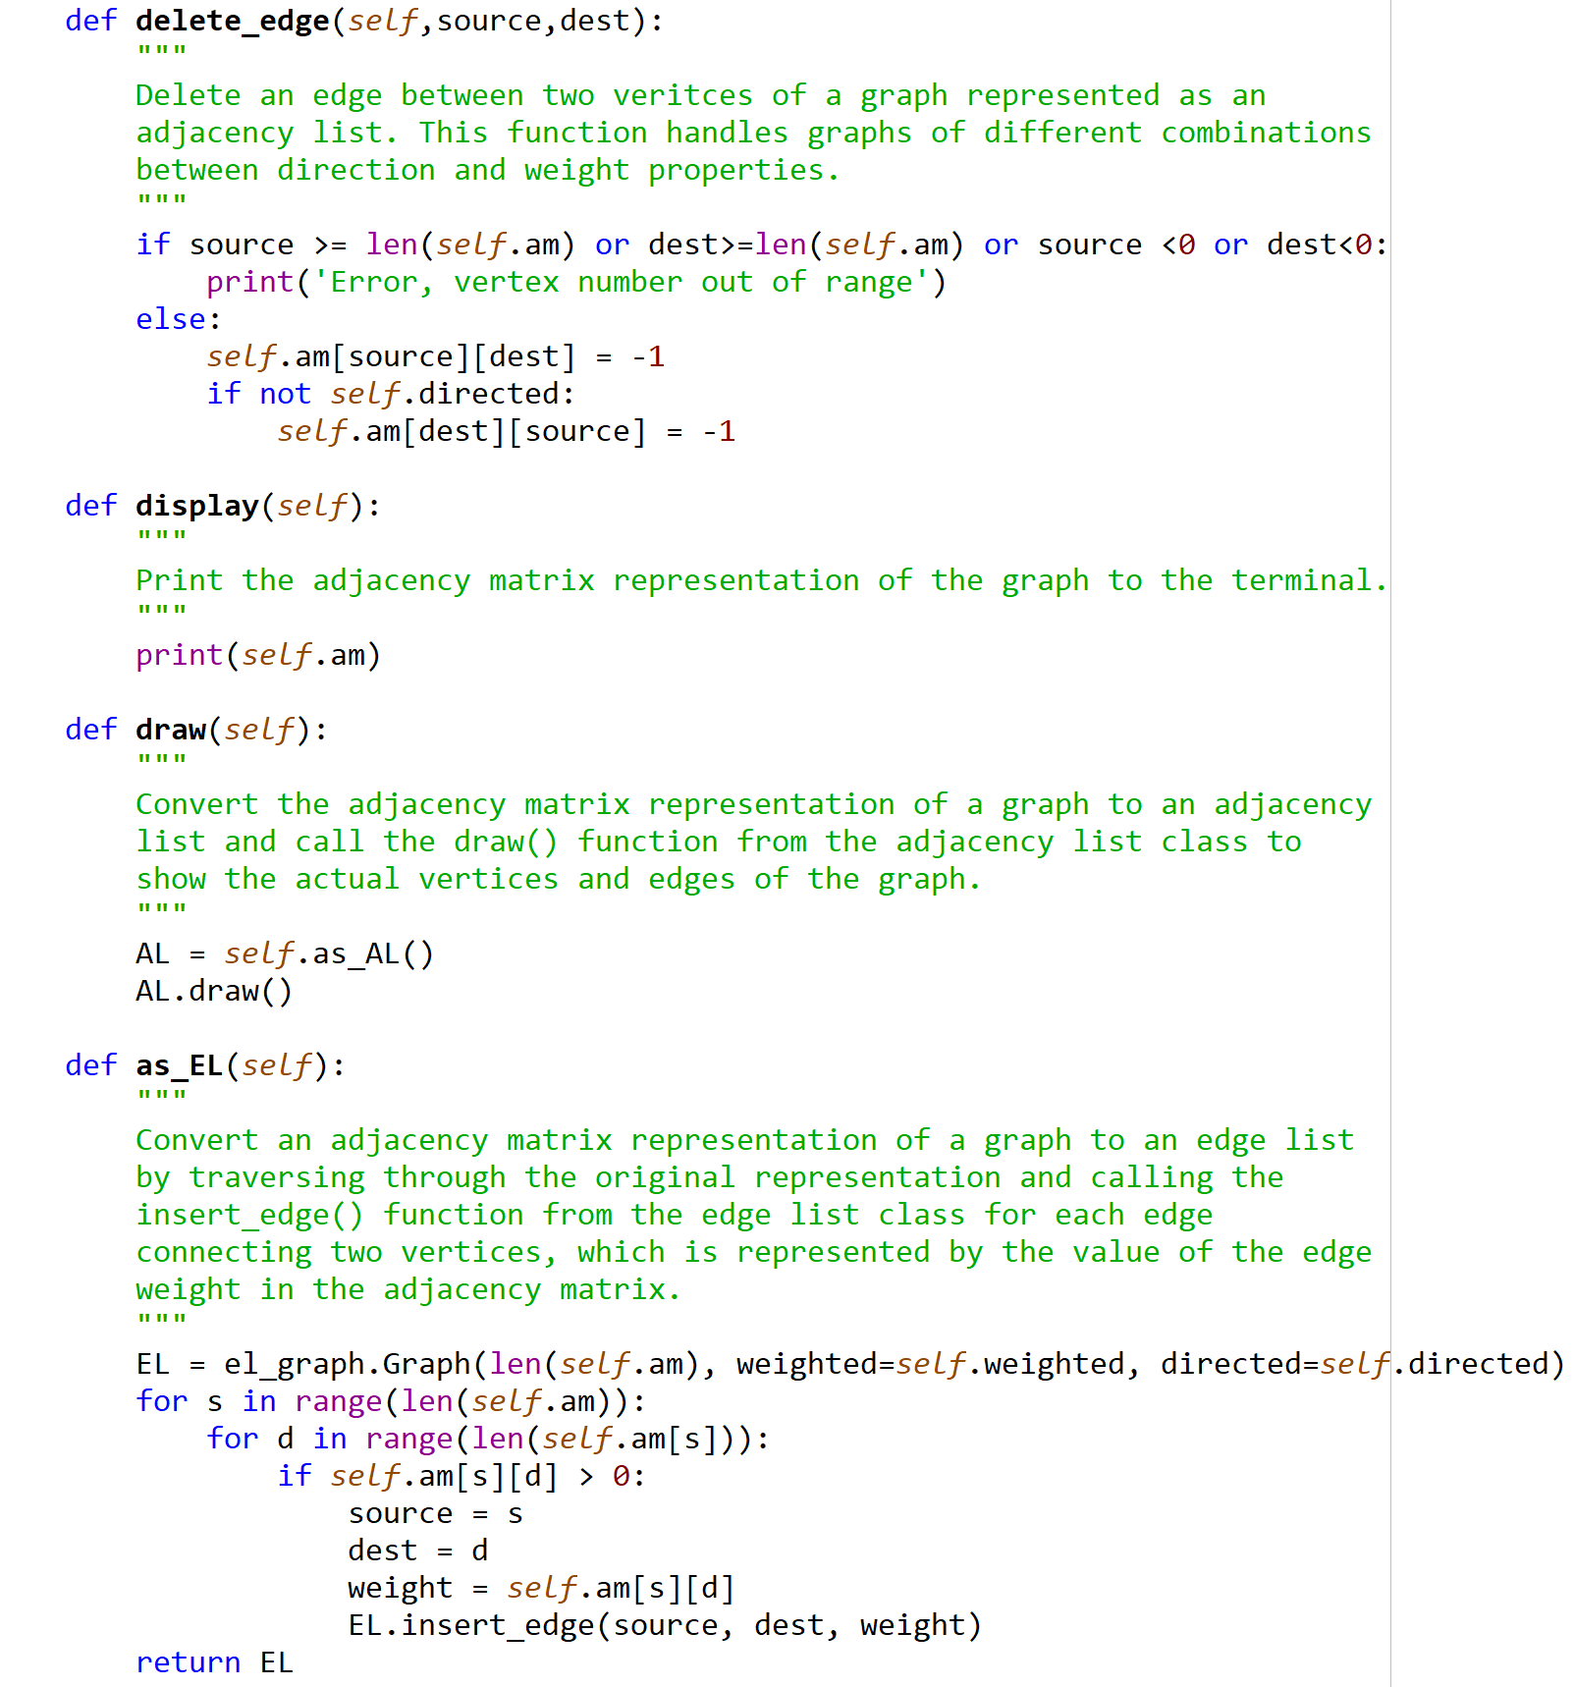

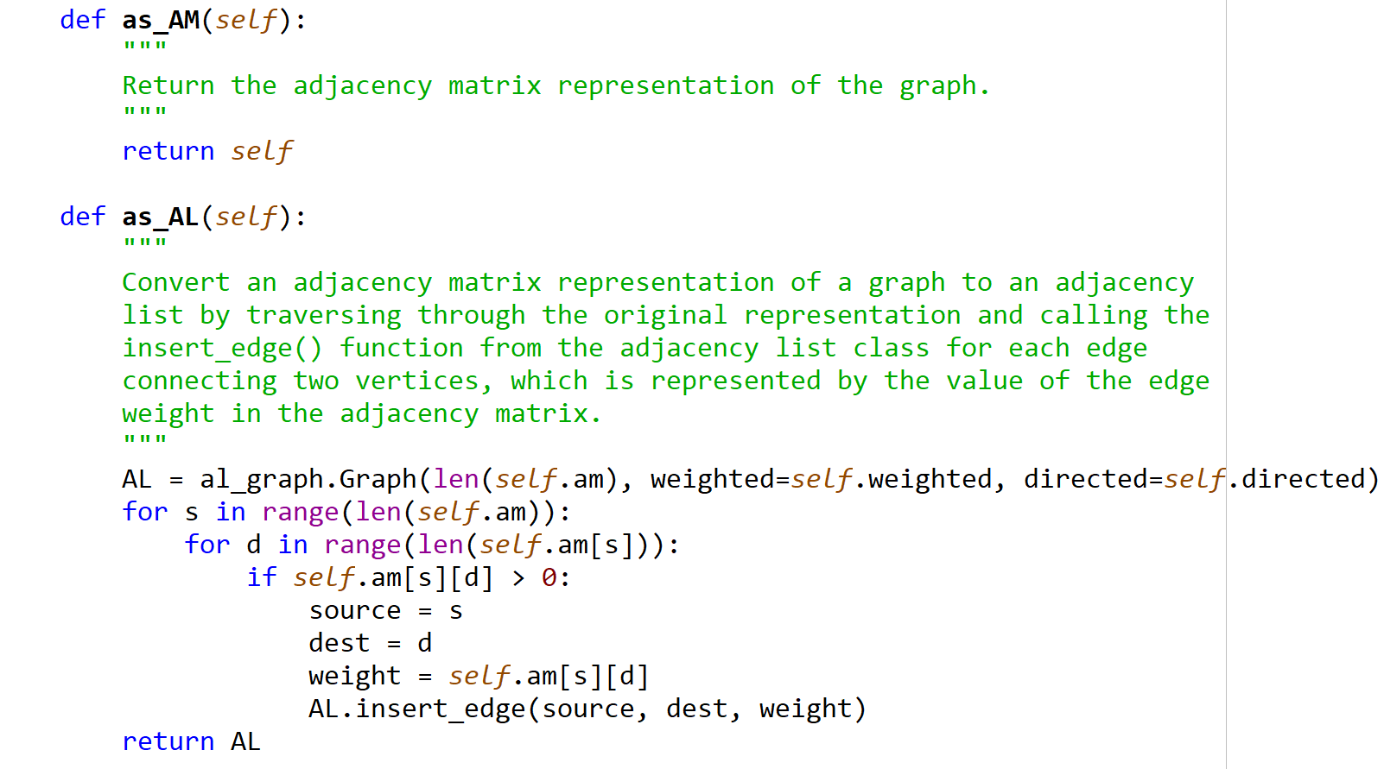



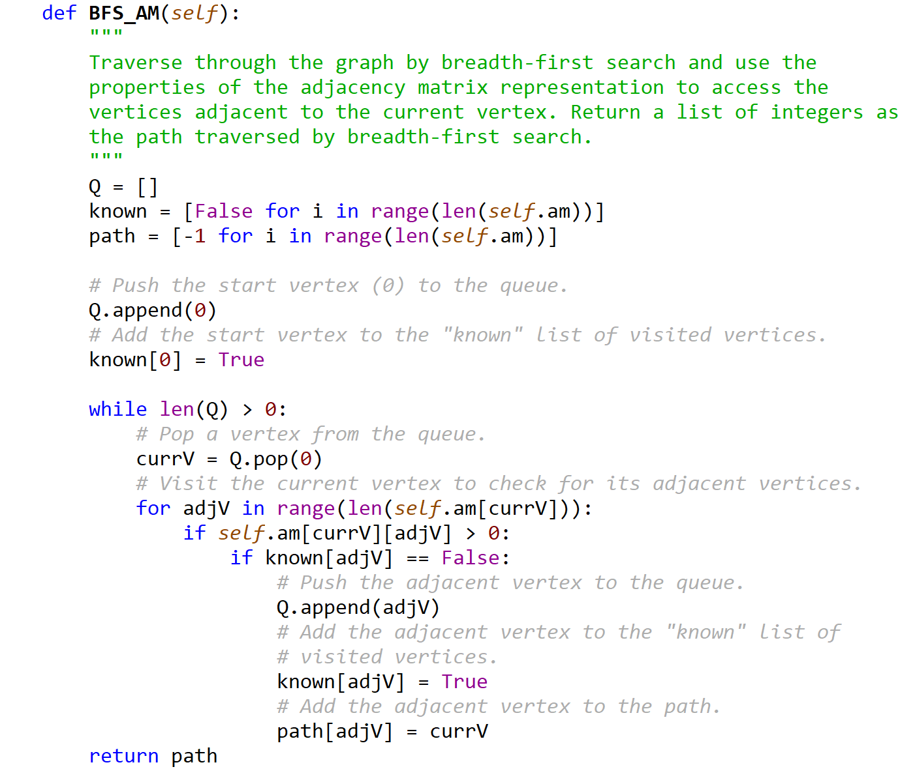

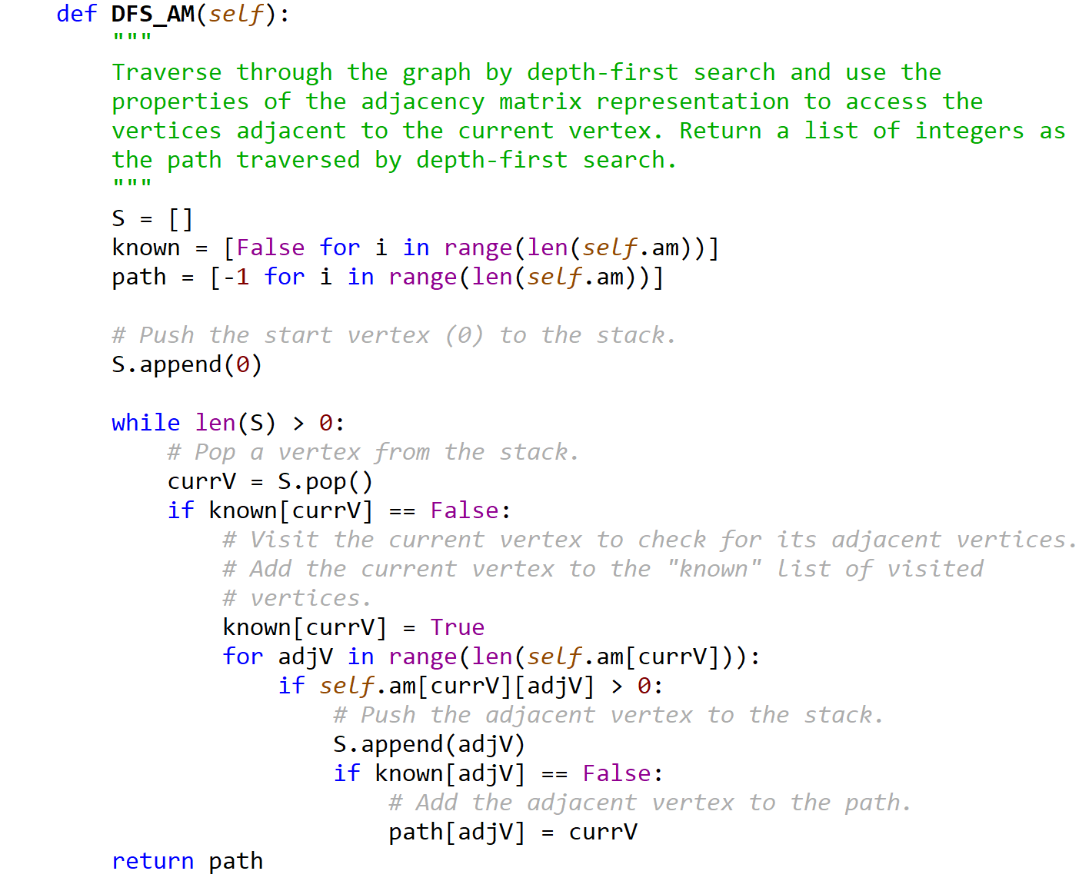

graph_EL.py

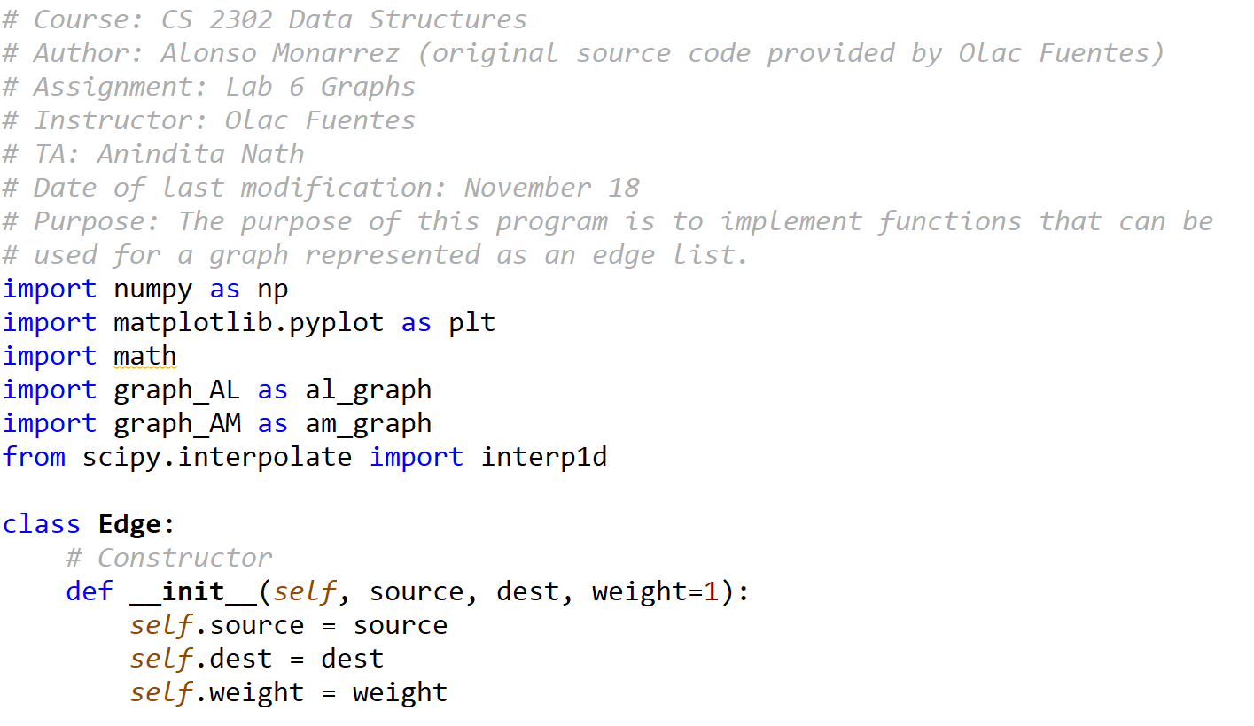



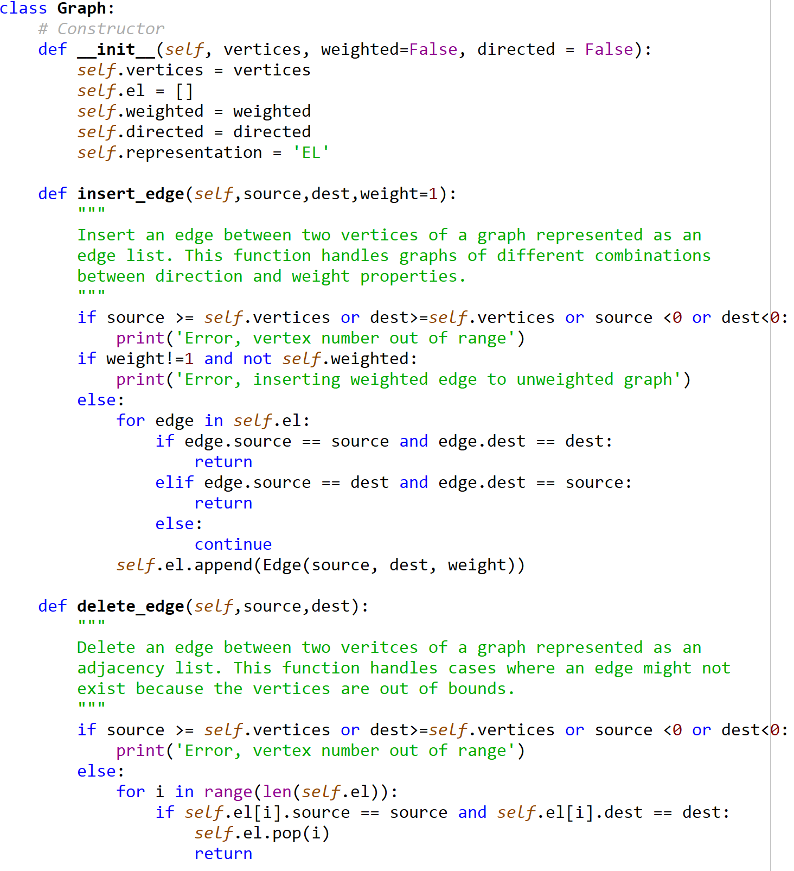

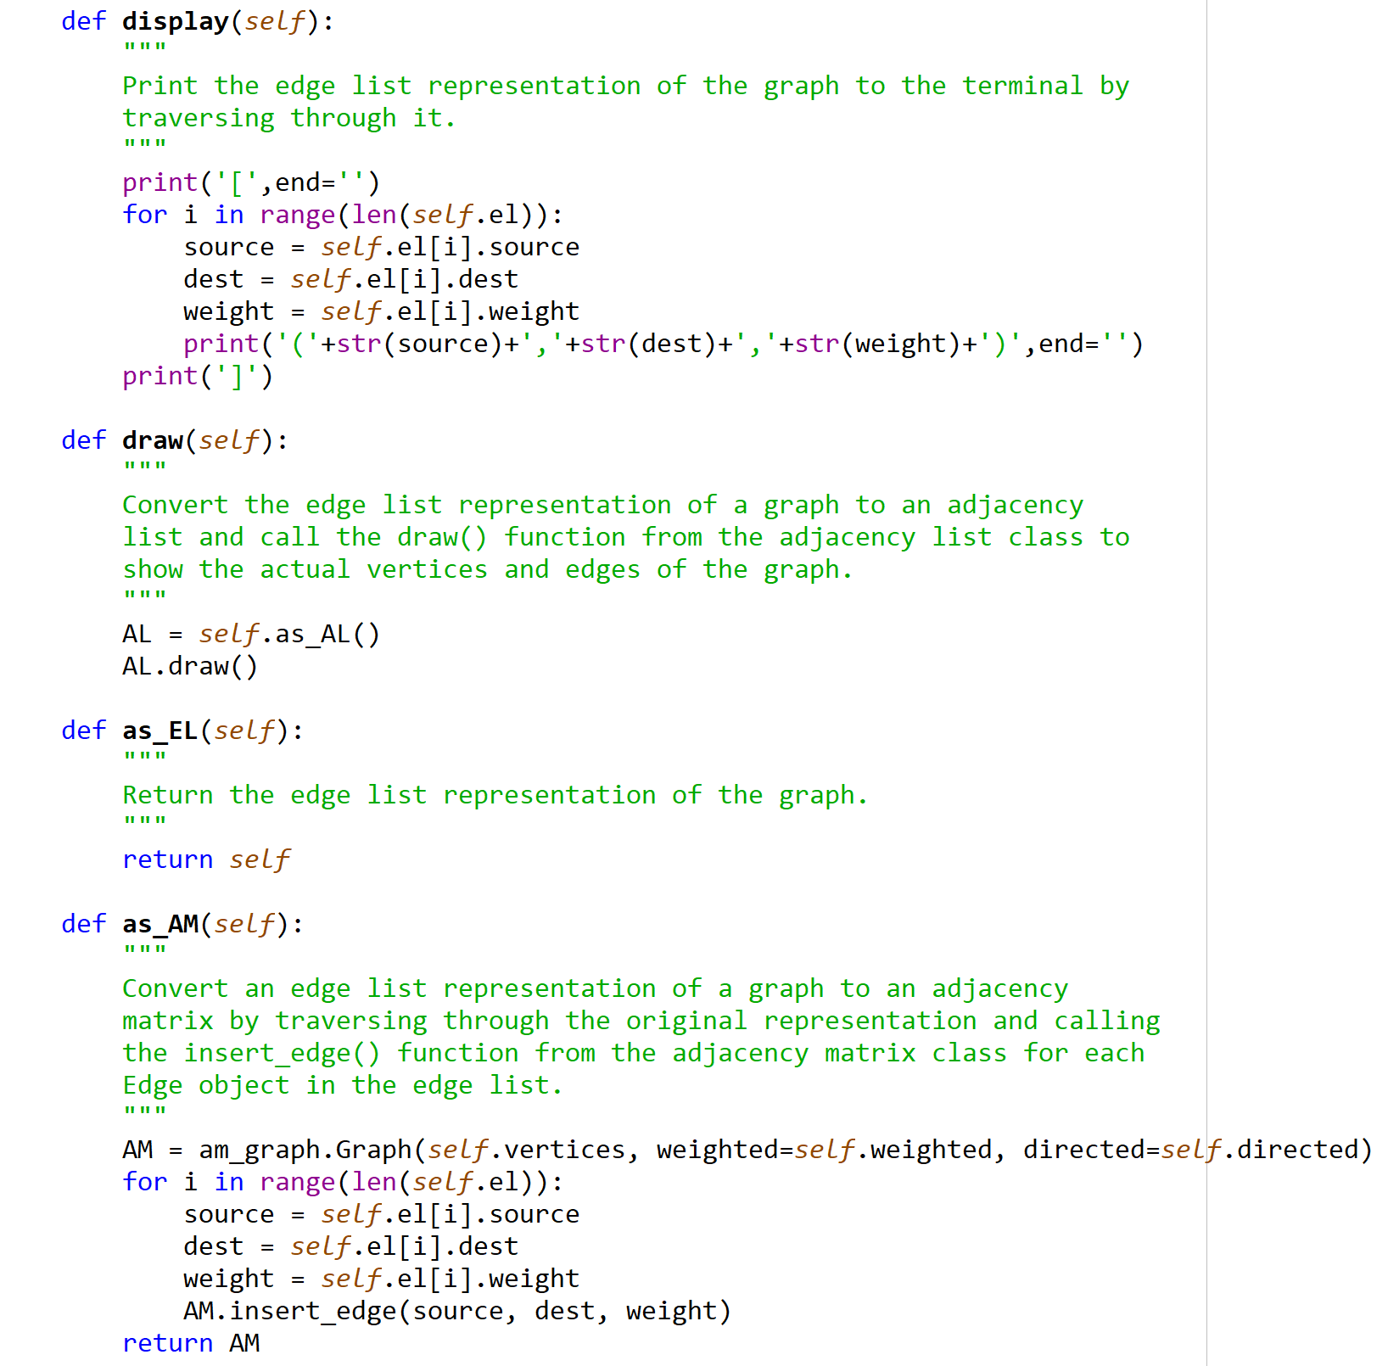

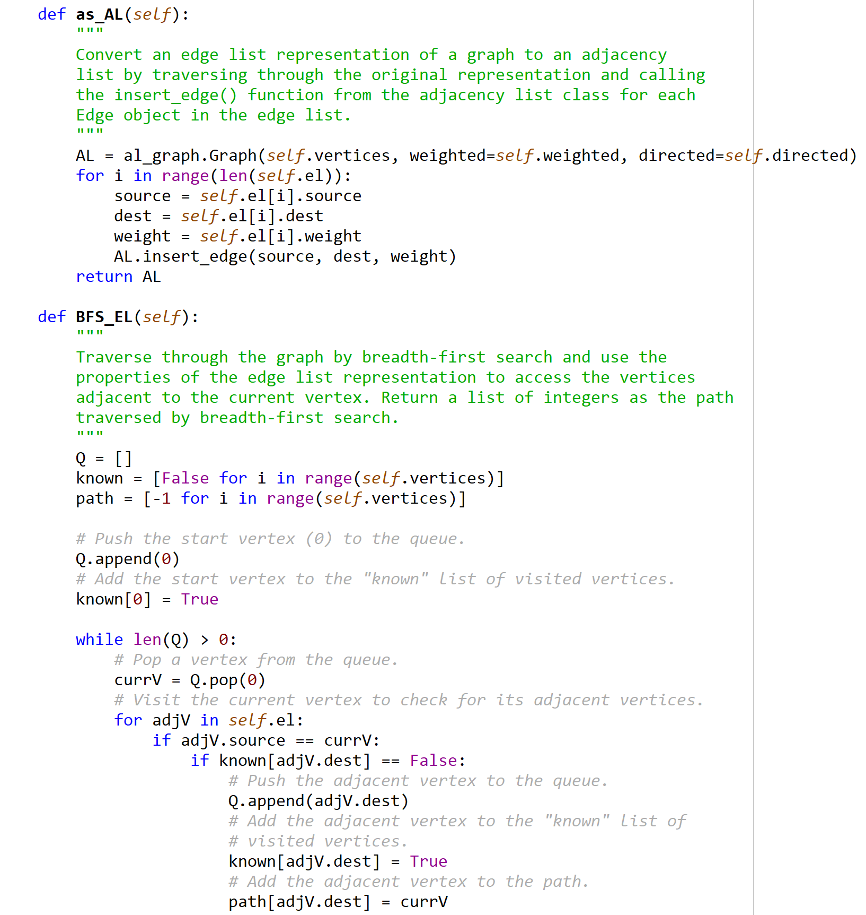

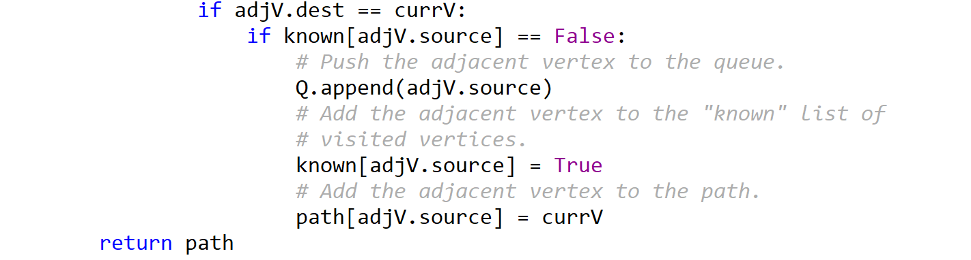

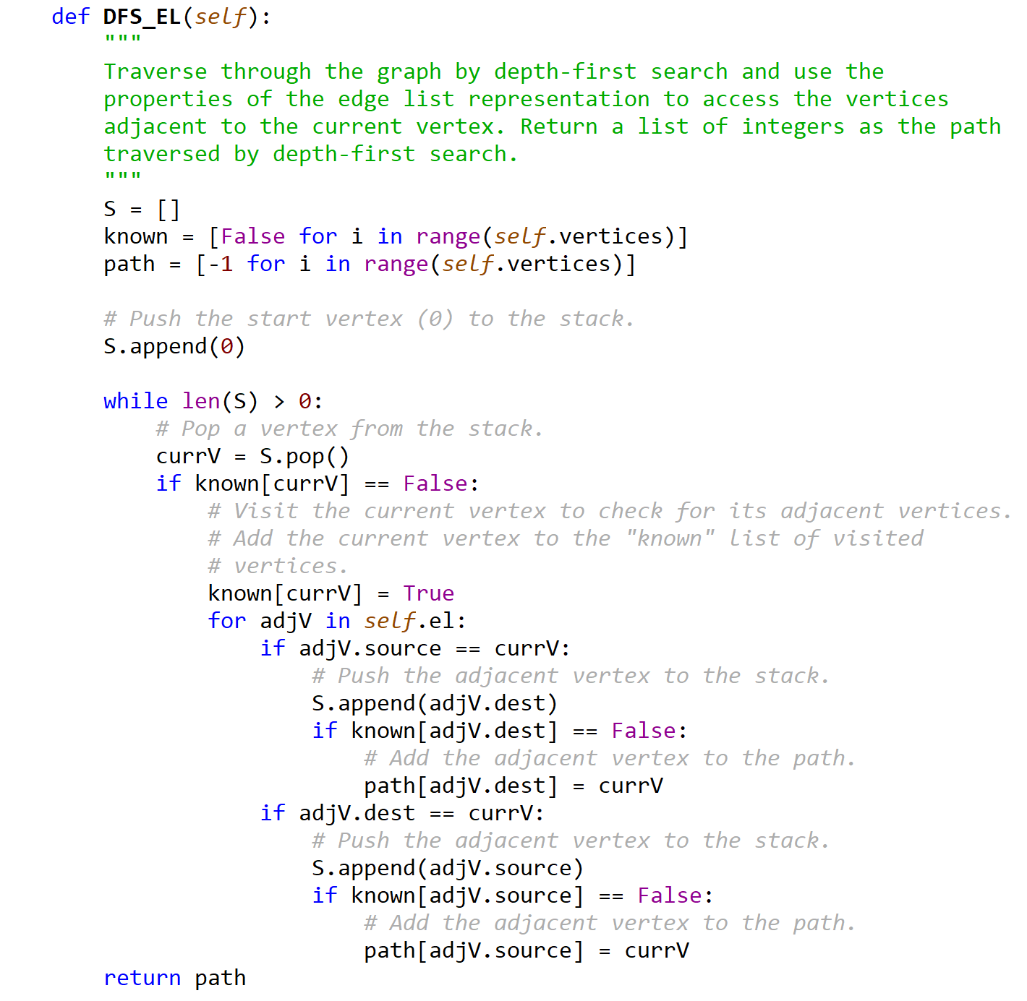

test_graphs.py

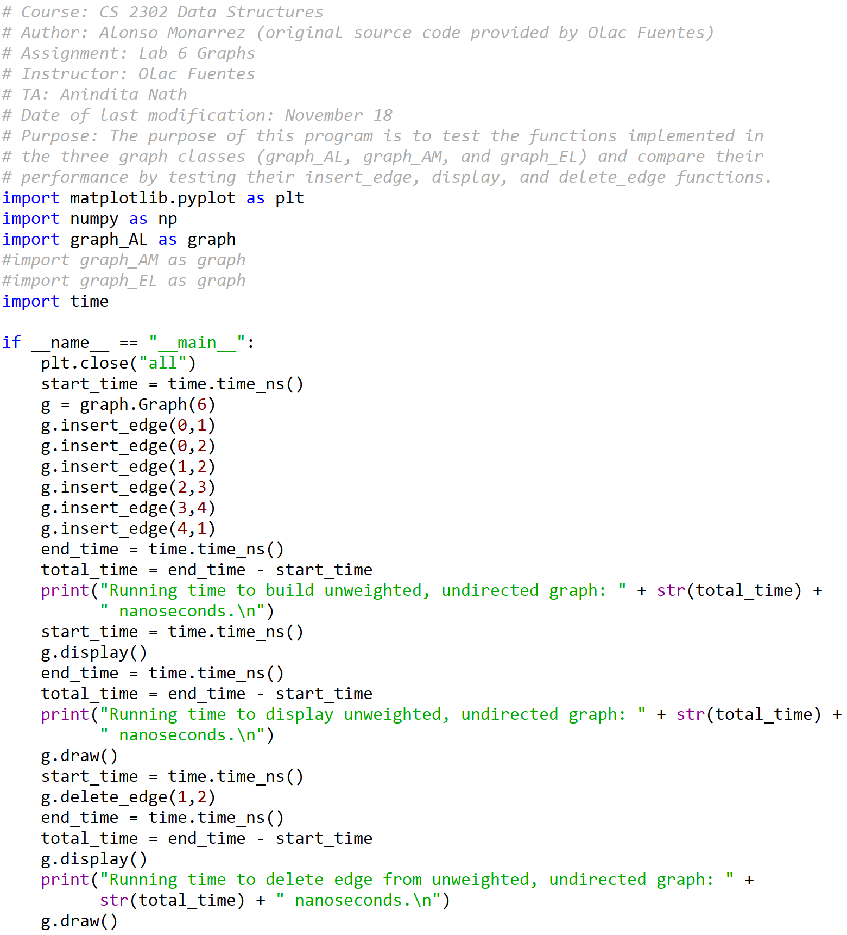

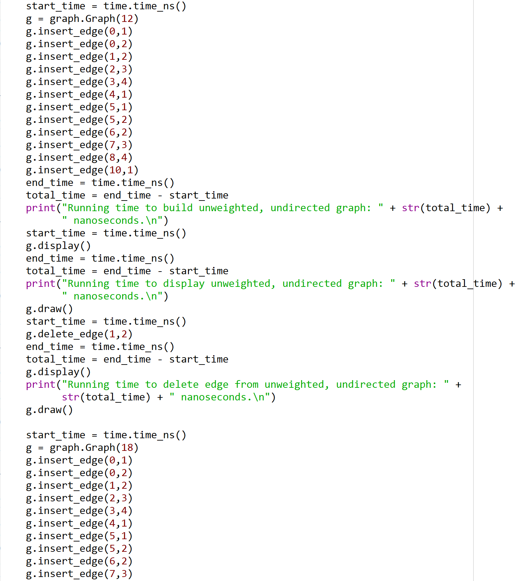

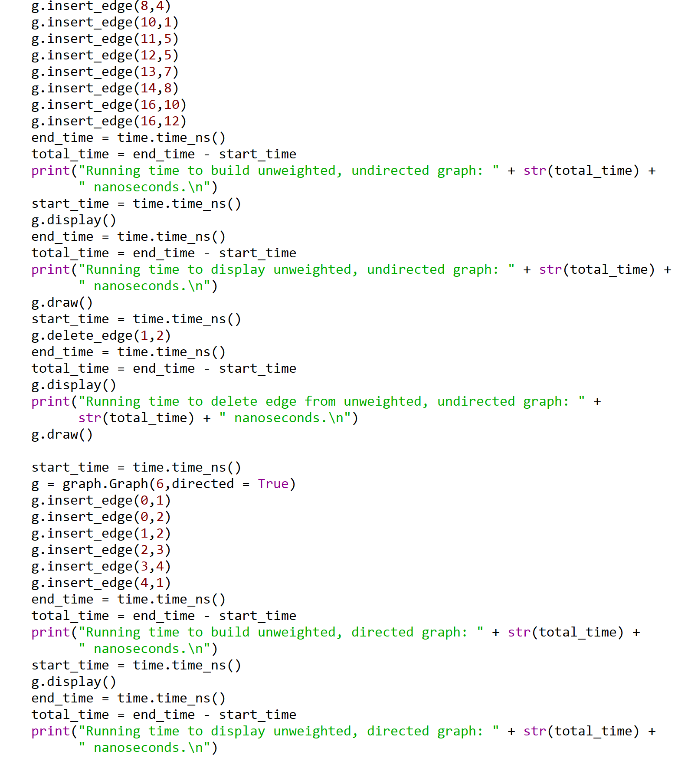

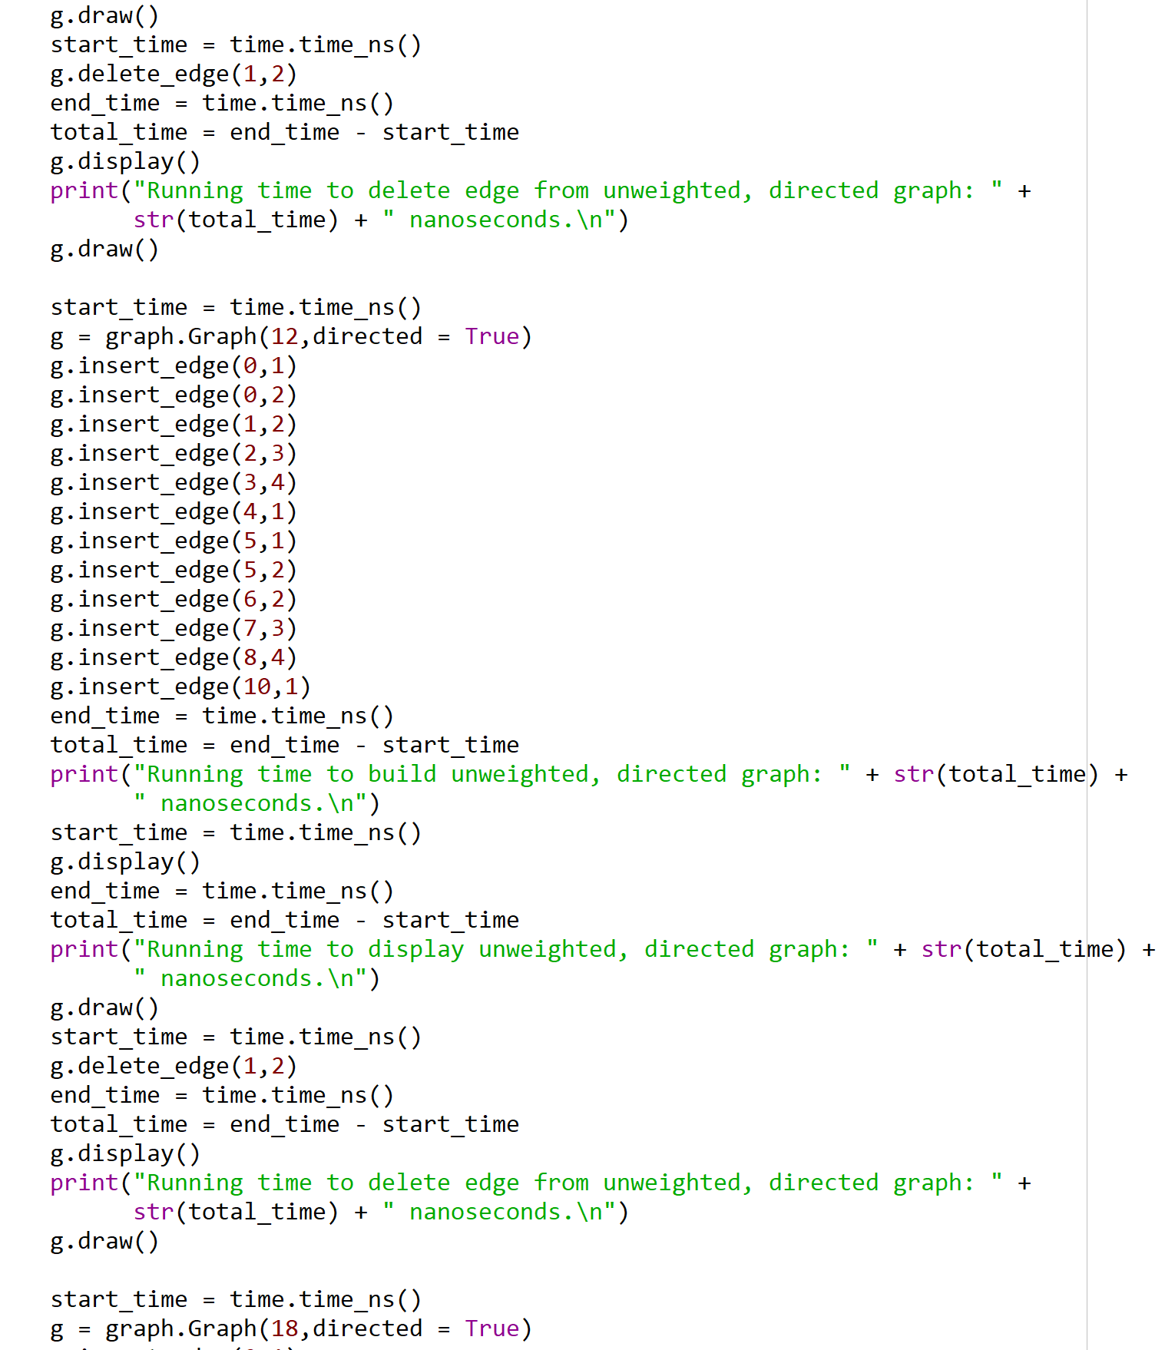

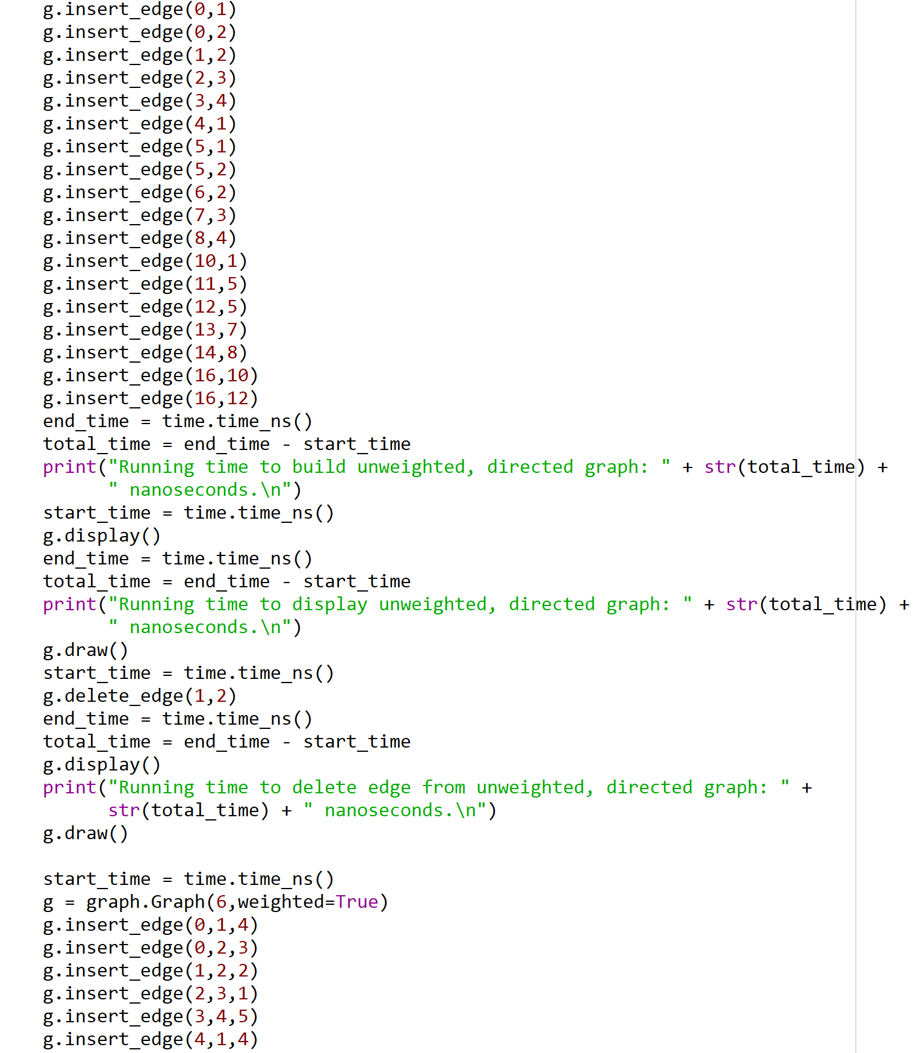

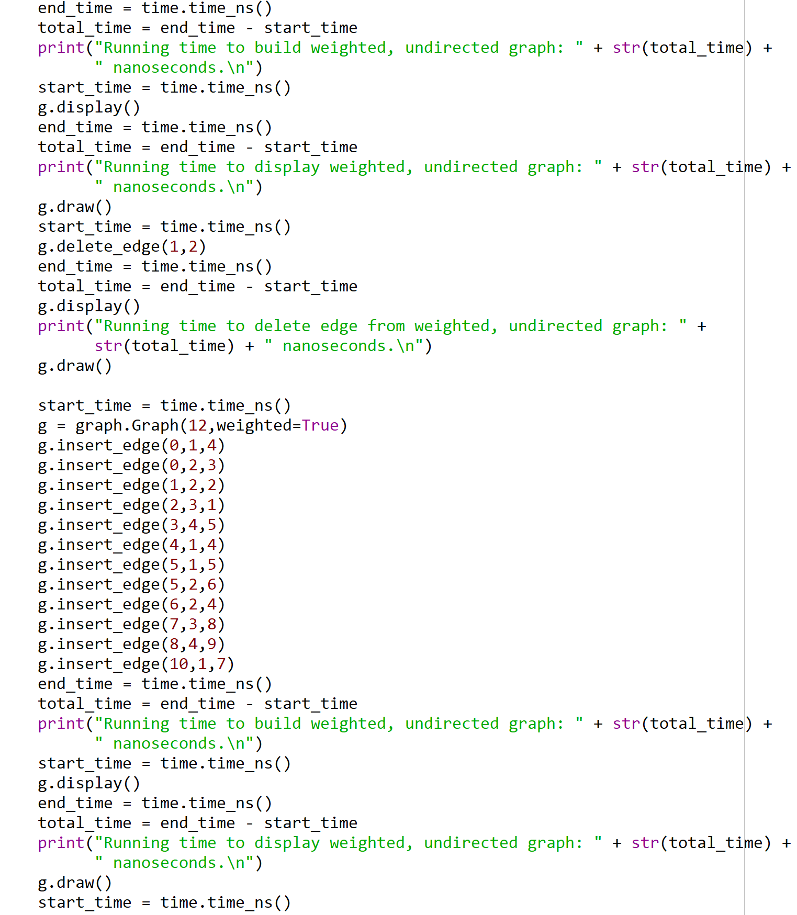

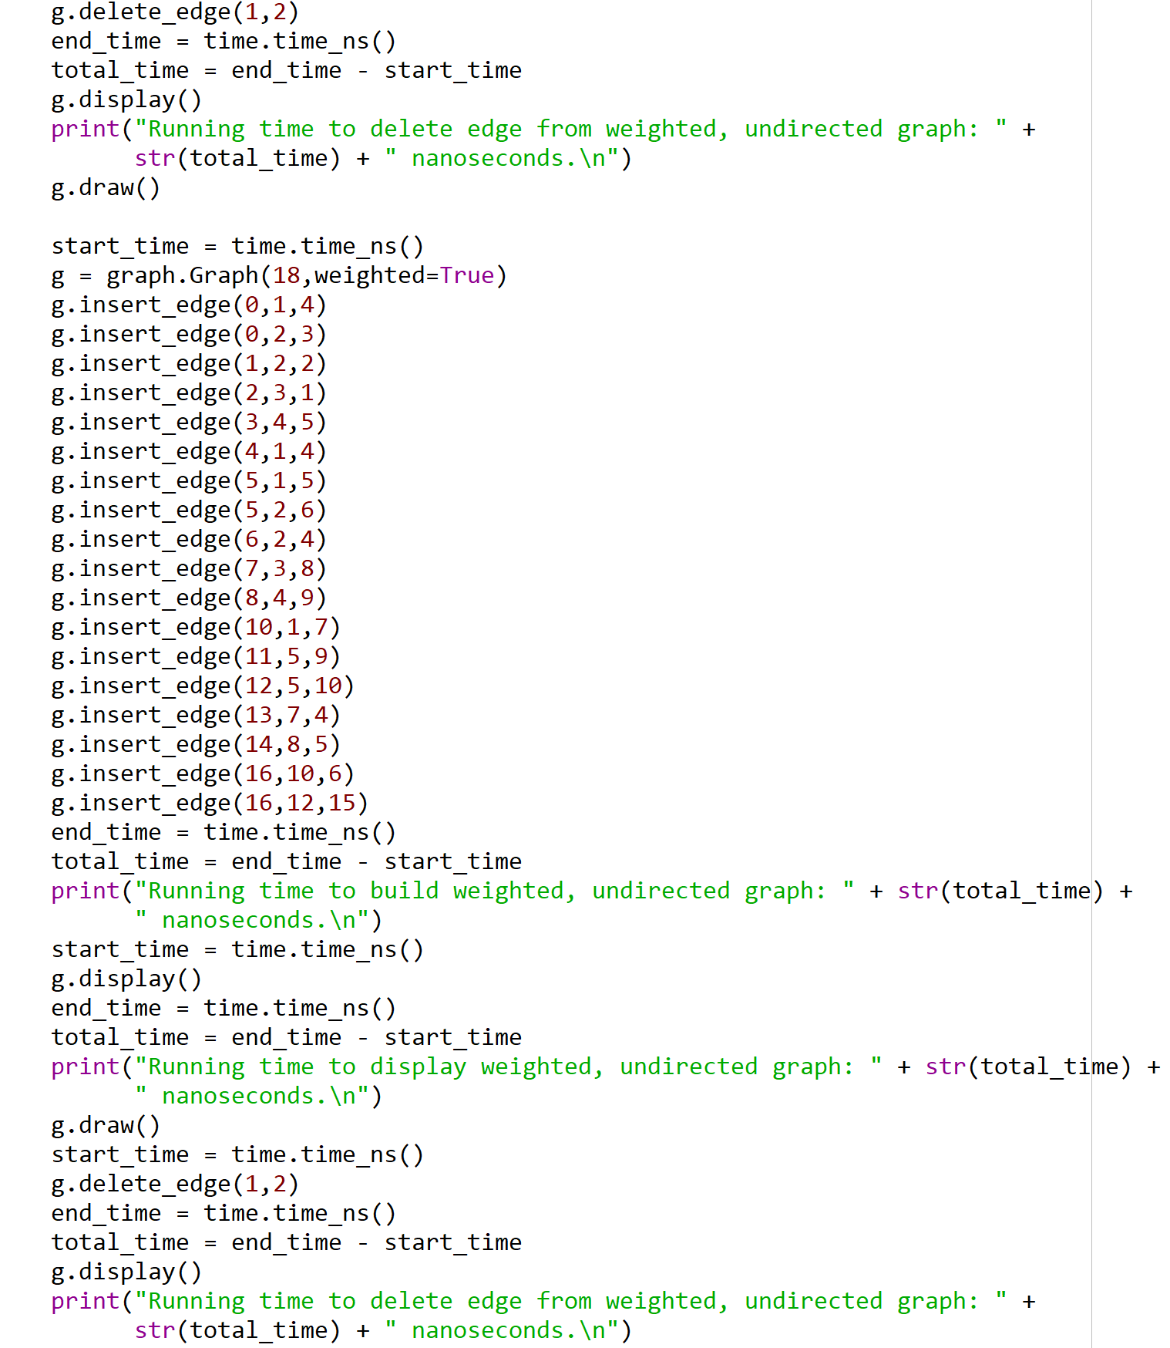

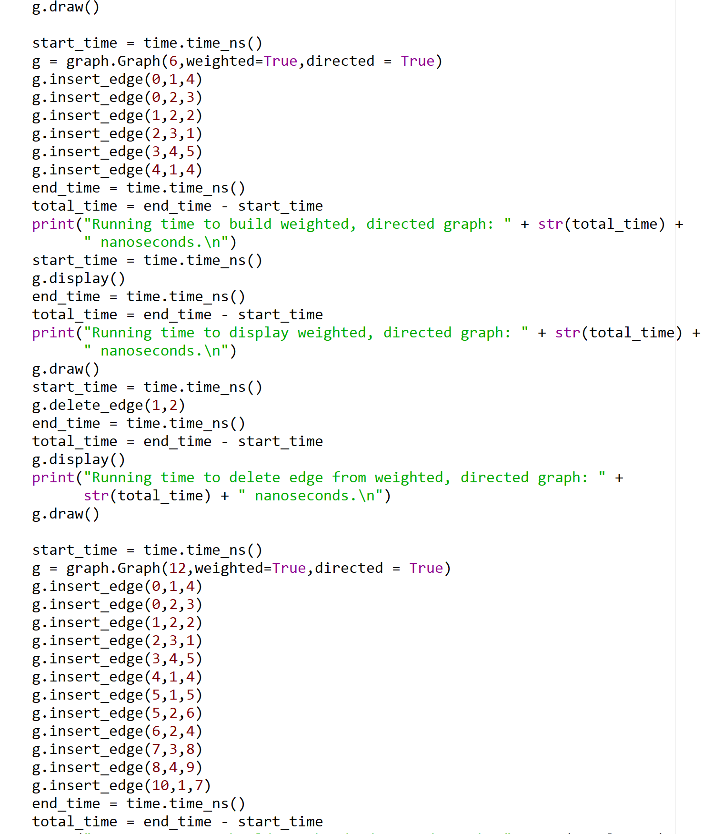

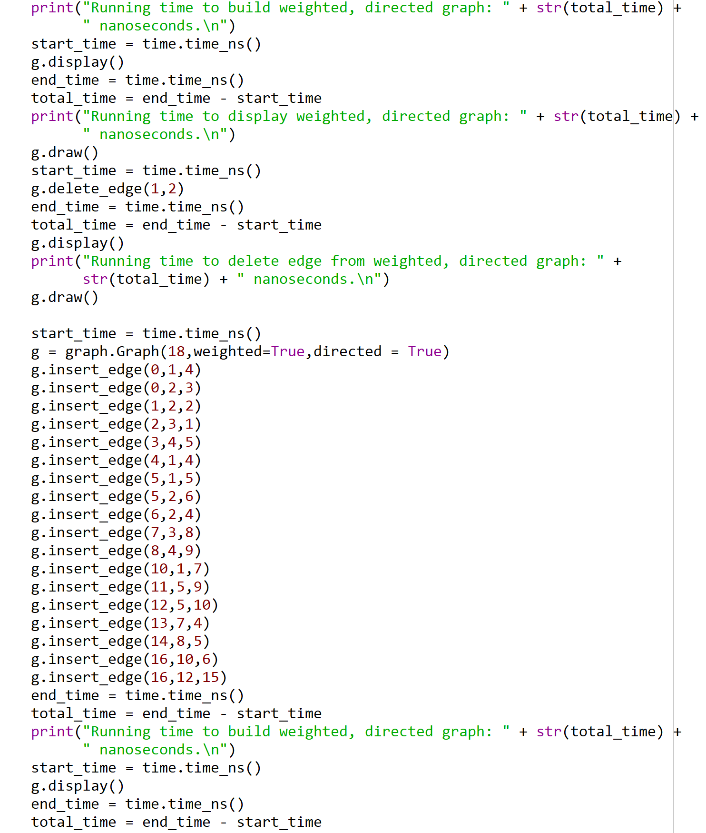

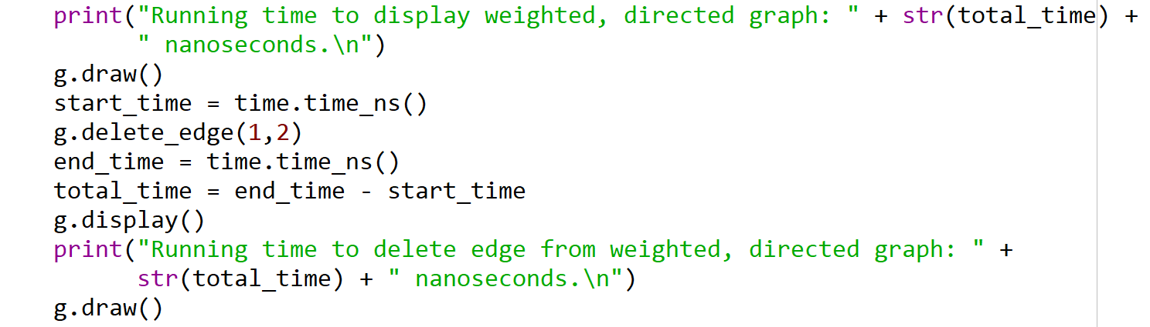

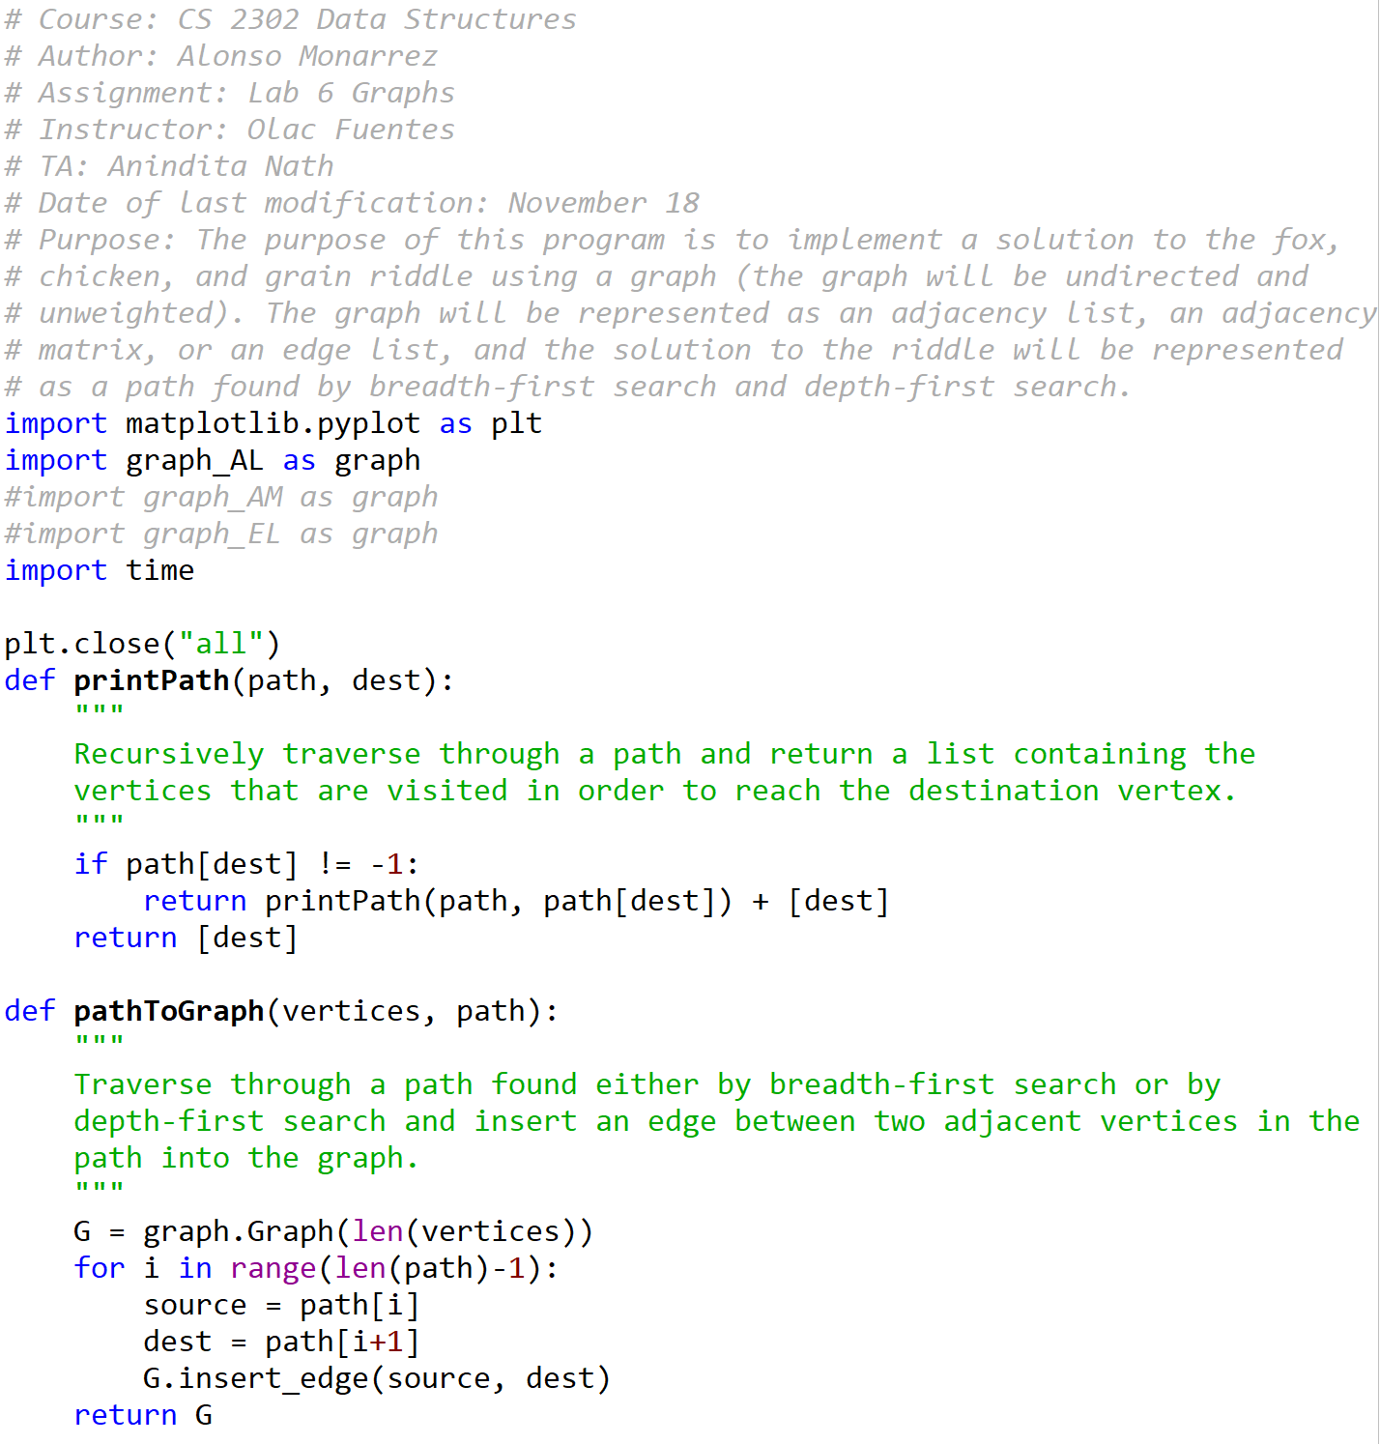

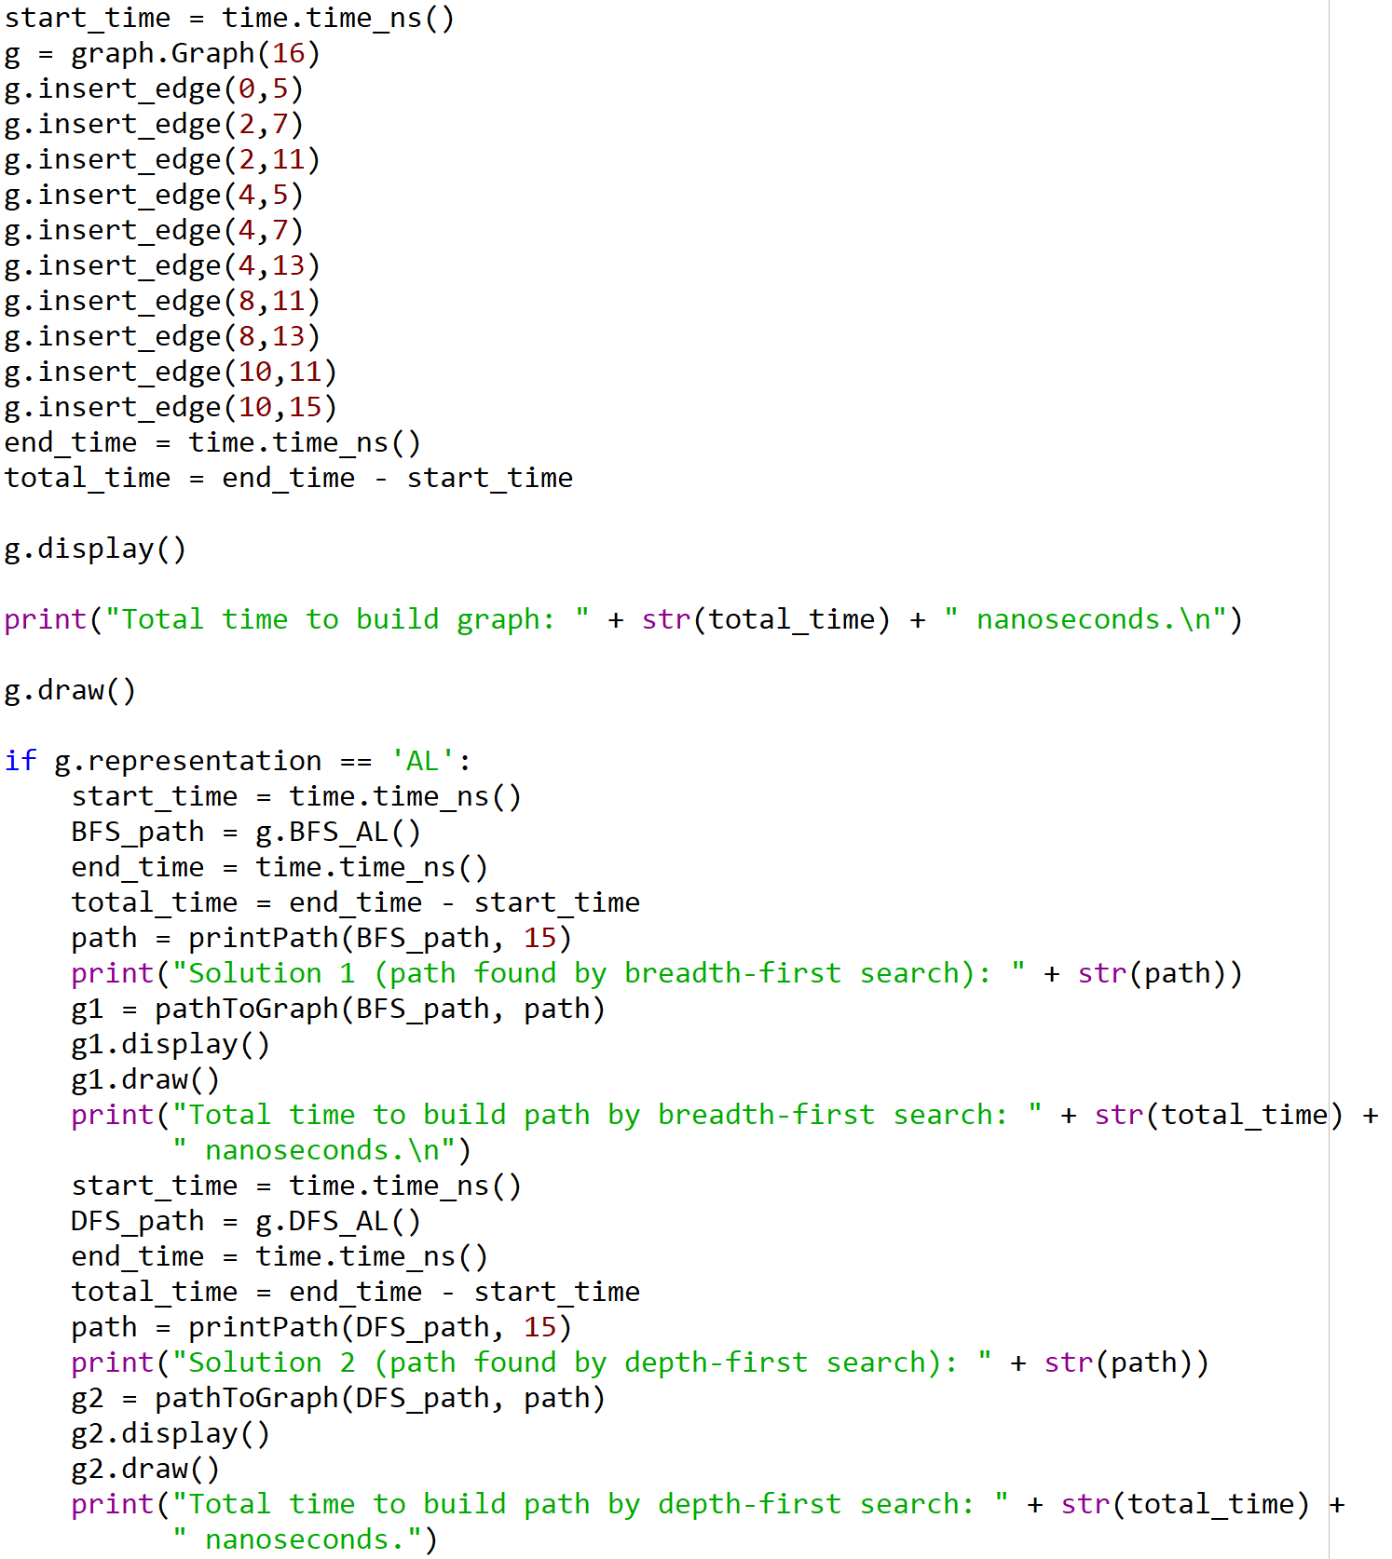

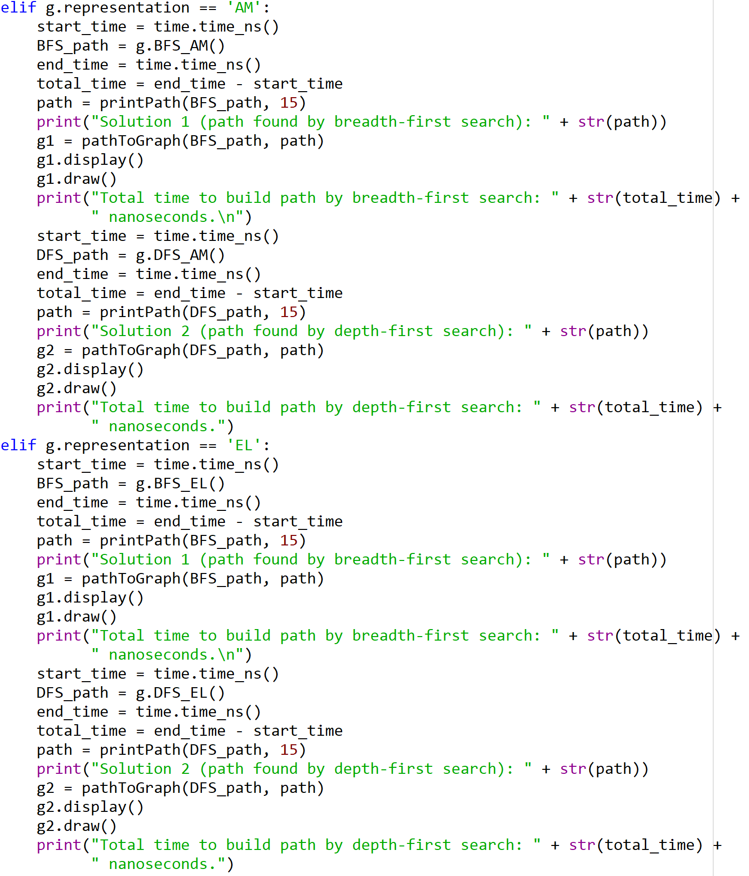

I certify that this project is entirely my own work. I wrote, debugged, and tested the code being presented, performed the experiments, and wrote the report. I also certify that I did not share my code or report or provided inappropriate assistance to any student in the class.